Saginaw First Free Methodist Church
Twenty-Third Sunday after Pentecost
November 8, 2020

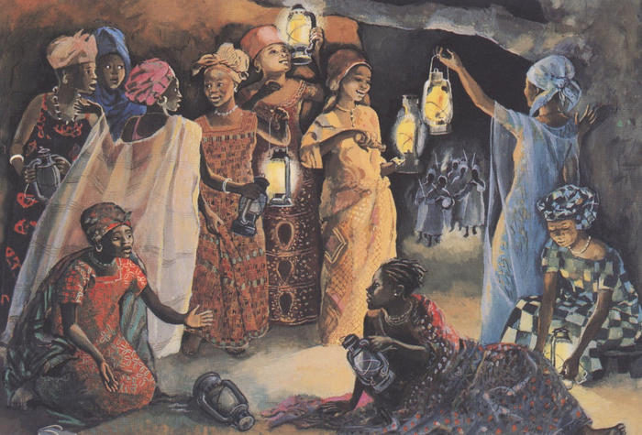
“’Then the kingdom of heaven will be like this. Ten bridesmaids took their lamps and went to meet the bridegroom.’” (Matthew 25:1)

Minister: Rev. Jason Evans
First Free Methodist Church
2625 N. Center Rd.
Saginaw, Michigan 48603
Phone: (989) 799-2930
Email: saginawfmc@gmail.com
www.saginawfirstfmc.org

Proper 27 (32)
November 8, 2020

The mission of Saginaw First Free Methodist Church is to be faithful to God and to make known to all people everywhere God’s call to wholeness in Jesus Christ.

Prelude
**Greeting/Announcements
*Call to Worship (spoken responsively)
L: Stand in awe of God, serve God in sincerity and in faithfulness
P: We will put away other gods and serve the LORD
L: God does not delight in our festivals or grain offerings
P: But let justice roll down like waters
L: The desire for wisdom leads to a kingdom of love
P: Where righteousness an ever-flowing stream
L: The LORD our God we will serve, and God we will obey
P: Let all who seek God rejoice and be glad

*Opening Hymn: “Angels, from the Realms of Glory” #192 (v.1)
Angels from the realms of glory
Wing your flight o'er all the earth
Ye who sang creation's story
Now proclaim Messiah's birth
Come and worship, come and worship
Worship Christ, the newborn king

*Invocation and Lord’s Prayer
L: Incarnate God, who came to us in flesh and blood, and abides with us in Spirit, reveal to us your truth. We come to you today, committing our lives to you, and ask that the Holy Spirit give us light. Reveal your will to us as we live active in our faith. Remind us that when we seek, we will find. May we worship you in Spirit and in Truth, as we pray together the prayer that Jesus taught His disciples…

P: Our Father, who art in heaven, hallowed be Your name. Your kingdom come; your will be done in earth as it is in heaven. Give us this day our daily bread and forgive us our debts as we forgive our debtors. And lead us not into temptation but deliver us from evil. For Yours is the kingdom, and the power, and the glory forever. Amen.

*Gloria Patri
Glory be to the Father​
And to the Son and to the Holy Ghost.
As it was in the beginning​
Is now and ever shall be
World without end
Amen. Amen

First Scripture Lesson: Joshua 24:1-3a, 14-25
Then Joshua gathered all the tribes of Israel to Shechem, and summoned the elders, the heads, the judges, and the officers of Israel; and they presented themselves before God. And Joshua said to all the people, “Thus says the LORD, the God of Israel: Long ago your ancestors--Terah and his sons Abraham and Nahor--lived beyond the Euphrates and served other gods. Then I took your father Abraham from beyond the River and led him through all the land of Canaan and made his offspring many.”
“Now therefore revere the LORD, and serve God in sincerity and in faithfulness; put away the gods that your ancestors served beyond the River and in Egypt, and serve the LORD. Now if you are unwilling to serve the LORD, choose this day whom you will serve, whether the gods your ancestors served in the region beyond the River or the gods of the Amorites in whose land you are living; but as for me and my household, we will serve the LORD.”
Then the people answered, “Far be it from us that we should forsake the LORD to serve other gods; for it is the LORD our God who brought us and our ancestors up from the land of Egypt, out of the house of slavery, and who did those great signs in our sight. Hod protected us along all the way that we went, and among all the peoples through whom we passed; and the LORD drove out before us all the peoples, the Amorites who lived in the land. Therefore we also will serve the LORD, for God is our God.”
But Joshua said to the people, “You cannot serve the LORD, for God is a holy God. God is a jealous God; God will not forgive your transgressions or your sins. If you forsake the LORD and serve foreign gods, then God will turn and do you harm, and consume you, after having done you good.”
And the people said to Joshua, “No, we will serve the LORD!”
Then Joshua said to the people, “You are witnesses against yourselves that you have chosen the LORD, to serve God.” And they said, “We are witnesses.”
He said, “Then put away the foreign gods that are among you, and incline your hearts to the LORD, the God of Israel.”
The people said to Joshua, “The LORD our God we will serve, and God we will obey.”
So Joshua made a covenant with the people that day, and made statutes and ordinances for them at Shechem.

Prayer of Confession
L: Our ancestors in the faith confessed to forsake everything but the LORD. But still they wandered away. We also make our allegiance to God, yet still follow our own biases. For the times we confuse God’s will with our own comfort, let us repent…

P: The beginning of wisdom is the most sincere desire for instruction. But we often prefer confirmation of our own biases. We say we follow the giver of all truth, the only way, who is light, but accept teachings that are rooted in falsehoods. We refuse providing for the foreigner, caring for the orphan, and bringing justice to the wronged. We seek prosperity for ourselves and loved ones, even if it denies those less fortunate. We seek your blessing only to bury it in a hole for ourselves. Teach us to live as a servant of all. Amen.

Affirmation of Faith: Hymnal 534
P: By the grace given to me, I say to everyone of you: Be devoted to one another in brotherly love. Honor one another above yourself. Share with God’s people who are in need. Live in harmony with one another. Do not be proud, but willing to associate with people who are of low position. Do not repay evil for evil. If your enemy is hungry, feed them. If your enemy is thirsty, give them something to drink. Do not be overcome by evil, but overcome evil with good. Seek good, not evil, that you may live. Then the Lord God Almighty will be with you.

*Hymn of Affirmation: “It Is Well With My Soul” #554 (v.1)
When peace like a river, attendeth my way,
When sorrows like sea billows roll
Whatever my lot, thou hast taught me to say
It is well, it is well, with my soul
It is well
With my soul
It is well, it is well with my soul

Second Scripture Lesson: 1 Thessalonians 4:13-18
But we do not want you to be uninformed, brothers and sisters, about those who have died, so that you may not grieve as others do who have no hope. For since we believe that Jesus died and rose again, even so, through Jesus, God will bring with him those who have died. For this we declare to you by the word of the Lord, that we who are alive, who are left until the coming of the Lord, will by no means precede those who have died.
For the Lord himself, with a cry of command, with the archangel’s call and with the sound of God's trumpet, will descend from heaven, and the dead in Christ will rise first. Then we who are alive, who are left, will be caught up in the clouds together with them to meet the Lord in the air; and so we will be with the Lord forever. Therefore encourage one another with these words.

Passing of the Peace

Prayers of the People
L: Lord in Your Mercy…
P: Hear our prayer.

Gospel Lesson: Matthew 25:1-13
“Then the kingdom of heaven will be like this. Ten bridesmaids took their lamps and went to meet the bridegroom. Five of them were foolish, and five were wise. When the foolish took their lamps, they took no oil with them; but the wise took flasks of oil with their lamps.
As the bridegroom was delayed, all of them became drowsy and slept. But at midnight there was a shout, ‘Look! Here is the bridegroom! Come out to meet him.’ Then all those bridesmaids got up and trimmed their lamps.
The foolish said to the wise, ‘Give us some of your oil, for our lamps are going out.’ But the wise replied, ‘No! there will not be enough for you and for us; you had better go to the dealers and buy some for yourselves.’
And while they went to buy it, the bridegroom came, and those who were ready went with him into the wedding banquet; and the door was shut. Later the other bridesmaids came also, saying, ‘Lord, lord, open to us.’ But he replied, ‘Truly I tell you, I do not know you.’
Keep awake therefore, for you know neither the day nor the hour.

Sermon

Prayer of Response

*Hymn of Response: “Take My Life, and Let It Be” #455 (v.5)
Take my will and make it thine
It shall be no longer mine
Take my heart it is thine own
It shall be thy royal throne
It shall be thy royal throne

Invitation of Offering
L: We have dedicated our lives to Christ, so bind yourselves to the call of justice. The world only cares for itself, but we are called to serve. How we care for the needy is a witness to our integrity. Give for your love of God and neighbor, as we collect this morning’s tithes and offerings.

*Doxology
Praise God, from whom all blessings flow
Praise Him, all creatures here below
Praise Him above, ye heavenly host
Praise Father Son, and Holy Ghost.
Amen.

*Prayer

*Hymn: “Send the Light” #705 (v.1)
There's a call comes ringing o'er the restless wave, “Send the light! Send the light”
There are souls to rescue, there are souls to save,
Send the light!
Send the light!
Send the light, the blessed gospel light;
Let it shine from shore to shore!
Send the light the blessed gospel light;
Let it shine forevermore!
*Benediction
L: God has sustained us to this very day, order your lives around service in return. Rejoice, for God Almighty abides with you. Share this joy with those around you. Set your hope in God, not man, as you go in peace to love and serve. Amen.

