Saginaw First Free Methodist Church
ASCENSION OF THE LORD
May 16, 2021

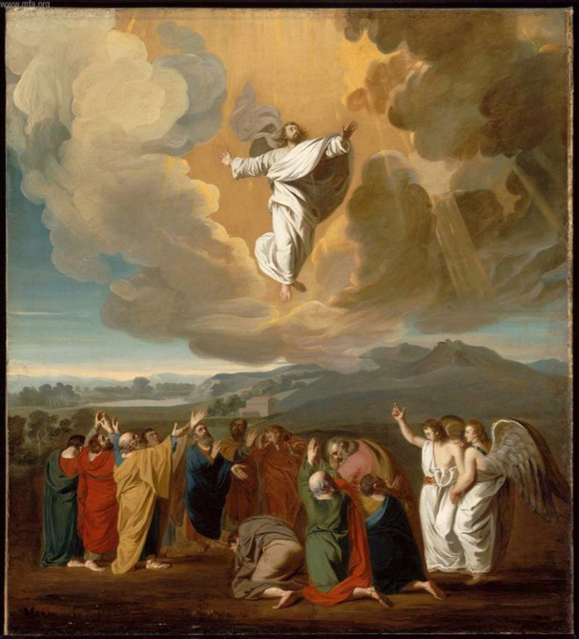
““Then he led them out as far as Bethany, and, lifting up his hands, he blessed them. While he was blessing them, he withdrew from them and was carried up into heaven.” (Luke 24:50-51)

Minister: Rev. Jason Evans
First Free Methodist Church
2625 N. Center Rd.
Saginaw, Michigan 48603
Phone: (989) 799-2930
Email: saginawfmc@gmail.com
www.saginawfirstfmc.org

ASCENSION OF THE LORD
May 16, 2021

The mission of Saginaw First Free Methodist Church is to be faithful to God and to make known to all people everywhere God’s call to wholeness in Jesus Christ.

Prelude
**Greeting/Announcements
*Call to Worship (spoken responsively)
L: All authority has been given to Christ Jesus
P: We gather expecting great things from God
L: You receive power from the Holy Spirit
P: We will be God’s witnesses on earth
L: We desire eyes of enlightened hearts
P: We pray for a spirit of wisdom and revelation
L: Christ is the head over all things
P: And we the church, the body of Christ

*Opening Hymn: “All Hail the Power of Jesus’ Name” #124 (vv.1-4)
All hail the power of Jesus' name!
Let angels prostrate fall
Bring forth the royal diadem
And crown him Lord of all
Bring forth the royal diadem
And crown him Lord of all!

Ye chosen seed of Israel's race
Ye ransomed from the fall
Hail him who saves you by his grace
And crown him Lord of all
Hail him who saves you by his grace
And crown him Lord of all!

Let every kindred every tribe
On this terrestrial ball
To him all majesty ascribe
And crown him Lord of all
To him all majesty ascribe
And crown him Lord of all!

Oh, that with yonder sacred throng
We at his feet may fall
We'll join the everlasting song
And crown him Lord of all
We'll join the everlasting song
And crown him Lord of all

*Invocation and Lord’s Prayer
L: Risen and ascended Christ, you surround us with witnesses and send us the Counselor who opens our minds to understand your teaching. Bless us with such grace that our lives may become a blessing for the world now, and in the age to come. May we know the joy of being one body of Christ here on earth, as we pray the prayer that Jesus taught His disciples…

P: Our Father, who art in heaven, hallowed be Your name. Your kingdom come; your will be done in earth as it is in heaven. Give us this day our daily bread and forgive us our debts as we forgive our debtors. And lead us not into temptation but deliver us from evil. For Yours is the kingdom, and the power, and the glory forever. Amen.

*Gloria Patri
Glory be to the Father​
And to the Son and to the Holy Ghost.
As it was in the beginning​
Is now and ever shall be
World without end
Amen. Amen

First Scripture Lesson: Acts 1:1-11
In the first book, Theophilus, I wrote about all that Jesus did and taught from the beginning until the day when he was taken up to heaven, after giving instructions through the Holy Spirit to the apostles whom he had chosen. After his suffering he presented himself alive to them by many convincing proofs, appearing to them during forty days and speaking about the kingdom of God.
While staying with them, he ordered them not to leave Jerusalem, but to wait there for the promise of the Father. “This,” he said, “is what you have heard from me; for John baptized with water, but you will be baptized with the Holy Spirit not many days from now.”
So when they had come together, they asked him, “Lord, is this the time when you will restore the kingdom to Israel?”
He replied, “It is not for you to know the times or periods that the Father has set by his own authority. But you will receive power when the Holy Spirit has come upon you; and you will be my witnesses in Jerusalem, in all Judea and Samaria, and to the ends of the earth.”
When he had said this, as they were watching, he was lifted up, and a cloud took him out of their sight. While he was going and they were gazing up toward heaven, suddenly two men in white robes stood by them. They said, “Men of Galilee, why do you stand looking up toward heaven? This Jesus, who has been taken up from you into heaven, will come in the same way as you saw him go into heaven.”

Prayer of Confession
L: Even forty days after the resurrection, the disciples were still looking for an earthly kingdom. Sometimes we too need our minds opened to God’s plan. As we seek the Holy Spirit’s instruction, let us confess…

P: I believe in one God the Father Almighty, Maker of heaven and earth, and of all things visible and invisible; And in one Lord Jesus Christ, the only-begotten Son of God, begotten of His Father before all worlds, God of God, Light of Light, very God of very God, begotten, not made, being of one substance with the Father, by whom all things were made; Who for us and for our salvation came down from heaven, and was incarnate by the Holy Spirit of the Virgin Mary, and was made man, and crucified also for us under Pontius Pilate; He suffered and was buried, and the third day He rose again according to the Scriptures, and ascended into heaven, and sitteth on the right hand of the Father; and He shall come again with glory to judge both the living and the dead; whose kingdom shall have no end. And I believe in the Holy Spirit, the Lord and Giver of Life, who proceedeth from the Father and the Son, who with the Father and the Son together is worshiped and glorified; who spoke by the prophets. And I believe in one holy universal and apostolic church; I acknowledge one baptism for the remission of sins; and I look for the resurrection of the dead, and the life of the world to come. Amen.

Affirmation of Faith: Psalm 47
P: Clap your hands, all you peoples; shout to God with loud songs of joy. For the LORD, the Most High, is awesome, a great king over all the earth. God has gone up with a shout, the LORD with the sound of a trumpet. Sing praises to our King. For God is the king of all the earth; sing praises with a psalm. God is king over the nations; God sits on the holy throne.

Hymn of Affirmation: “Majesty” #122 (x2)
Majesty, worship His majesty
Unto Jesus, be all glory, honor, and praise
Majesty, kingdom authority
Flow from His throne unto His own, His anthem raise
So exalt, lift up on high, the name of Jesus
Magnify, come glorify, Christ Jesus the King
Majesty, worship His majesty
Jesus who died, now glorified, King of all Kings

Second Scripture Lesson: Ephesians 1:15-23
I have heard of your faith in the Lord Jesus and your love toward all the saints, and for this reason I do not cease to give thanks for you as I remember you in my prayers.
I pray that the God of our Lord Jesus Christ, the Father of glory, may give you a spirit of wisdom and revelation as you come to know him, so that, with the eyes of your heart enlightened, you may know what is the hope to which he has called you, what are the riches of his glorious inheritance among the saints, and what is the immeasurable greatness of his power for us who believe, according to the working of his great power.
God put this power to work in Christ when he raised him from the dead and seated him at his right hand in the heavenly places, far above all rule and authority and power and dominion, and above every name that is named, not only in this age but also in the age to come. And he has put all things under his feet and has made him the head over all things for the church, which is his body, the fullness of him who fills all in all.

Passing of the Peace

Prayers of the People
L: Lord in Your Mercy…
P: Hear our prayer.

Gospel Lesson: Luke 24:44-53
Then he said to them, “These are my words that I spoke to you while I was still with you, that everything written about me in the law of Moses, the prophets, and the psalms must be fulfilled.”
Then he opened their minds to understand the scriptures, and he said to them, “Thus it is written, that the Messiah is to suffer and to rise from the dead on the third day, and that repentance and forgiveness of sins is to be proclaimed in his name to all nations, beginning from Jerusalem. You are witnesses of these things. And see, I am sending upon you what my Father promised; so stay here in the city until you have been clothed with power from on high.”
Then he led them out as far as Bethany, and, lifting up his hands, he blessed them. While he was blessing them, he withdrew from them and was carried up into heaven. And they worshiped him, and returned to Jerusalem with great joy; and they were continually in the temple blessing God.

Sermon

Prayer of Response

*Hymn of Response: “Crown Him with Many Crowns” #272 (vv.1,3-4)
Crown him with many crowns
The Lamb upon his throne
Hark! how the heavenly anthem drowns
All music but its own
Awake, my soul, and sing
Of him who died for thee
And hail him as thy matchless king
Through all eternity

Crown him the Lord of life
Who triumphed o'er the grave
Who rose victorious to the strife
For those he came to save
His glories now we sing
Who died and rose on high
Who died eternal life to bring
And lives that death may die

Crown him the Lord of Heaven
One with the Father known
One with the Spirit thro’ Him given
From yonder glorious throne
To Thee be endless praise
For thou for us hast died
Be Thou, O Lord, thro’ endless days
Adored and magnified

Invitation of Offering
L: The Kingdom of God is not like the ones of this world. We sacrifice so that all peoples may experience joy of the risen and ascended savior. Give in faith, as we collect this morning’s tithes and offerings.

*Doxology
Praise God, from whom all blessings flow
Praise Him, all creatures here below
Praise Him above, ye heavenly host
Praise Father Son, and Holy Ghost.
Amen.

*Prayer

*Hymn: “Heaven Came Down” #371 (vv.1-3)
O what a wonderful, wonderful day
Day I will never forget
After I'd wandered in darkness away
Jesus my Savior I met
O what a tender, compassionate friend
He met the need of my heart
Shadows dispelling, With joy I am telling
He made all the darkness depart
Heaven came down and glory filled my soul
When at the cross the Savior made me whole
My sins were washed away
And my night was turned to day
Heaven came down and glory filled my soul

Born of the Spirit with life from above
Into God's fam'ly divine
Justified fully thru Calvary's love
O what a standing is mine
And the transaction so quickly was made
When as a sinner I came,
Took of the offer of grace He did proffer
He saved me, O praise His dear name
Heaven came down and glory filled my soul
When at the cross the Savior made me whole
My sins were washed away
And my night was turned to day
Heaven came down and glory filled my soul

Now I've a hope that will surely endure
After the passing of time
I have a future in heaven for sure
There in those mansions sublime
And it's because of that wonderful day
When at the cross I believed
Riches eternal and blessings supernal
From His precious hand I received
Heaven came down and glory filled my soul
When at the cross the Savior made me whole
My sins were washed away
And my night was turned to day
Heaven came down and glory filled my soul

*Benediction
L: Baptized and empowered by the Holy Spirit, we are designed to be the church. We are witnesses of God’s love and mercy. Take this hope to the ends of the earth, as you go in peace to love and serve. Amen.

