Saginaw First Free Methodist Church
Fifth Sunday In Lent
March 29, 2020

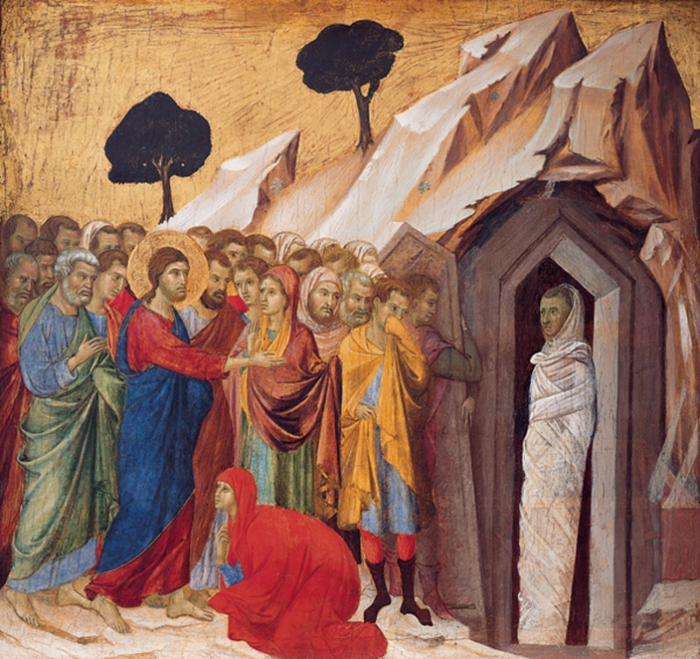

“When he had said this, he cried with a loud voice, ‘Lazarus, come out!’ The dead man came out, his hands and feet bound with strips of cloth, and his face wrapped in a cloth. Jesus said to them, ‘Unbind him, and let him go.’” (John 11:43-44)

Minister: Rev. Jason Evans
First Free Methodist Church
2625 N. Center Rd.
Saginaw, Michigan 48603
Phone: (989) 799-2930
Email: saginawfmc@gmail.com
www.saginawfirstfmc.org

Fifth Sunday In Lent
March 29, 2020

The mission of Saginaw First Free Methodist Church is to be faithful to God and to make known to all people everywhere God’s call to wholeness in Jesus Christ.

Prelude
Greeting/Announcements
Call to Worship (spoken responsively)
L: God calls us from the valley of dry bones
P: We hear God calling us in a booming voice
L: The Spirit breathes life into our dry bones
P: Our souls wait for the refreshment God offers
L: God offers hope when we have lost our way
P: Christ is the light of the world
L: We are filled with great expectations
P: Christ heals all our bodies bringing us to new life

*Opening Hymn: “Immortal, Invisible, God Only Wise”

Immortal, invisible, God only wise
In light inaccessible hid from our eyes
Most blessed, most glorious, the Ancient of Days
Almighty, victorious, thy great name we praise

Unresting, unhasting, and silent as light
Nor wanting, nor wasting, thou rulest in might
Thy justice like mountains high soaring above
Thy clouds which are fountains of goodness and love

To all, life Thou givest, to both great and small
In all life Thou livest, the true life of all
Thy wisdom so boundless, Thy mercy so free
Eternal Thy goodness, for naught changeth Thee

Great Father of glory, pure Father of light
Thine angels adore thee, all veiling their sight
All laud we would render; O help us to see
Tis only the splendor of light hideth thee!

Invocation and Lord’s Prayer
L: God of the covenant, in the glory of the cross your Son embraced the power of death and broke its hold over your people. In this time, draw all people to yourself, that we who confess Jesus as Lord may put aside the deeds of death and accept the life of your kingdom. Give us hope and endurance to live lives of faith. Breath on us breath of God, as we pray the prayer that Jesus taught His disciples…

P: Our Father, who art in heaven, hallowed be Your name. Your kingdom come; your will be done in earth as it is in heaven. Give us this day our daily bread and forgive us our debts as we forgive our debtors. And lead us not into temptation but deliver
us from evil. For Yours is the kingdom, and the power, and the glory forever. Amen.

Gloria Patri

Old Testament Scripture Lesson: Ezekiel 37:1-14
The hand of the LORD came upon me, and he brought me out by the spirit of the LORD and set me down in the middle of a valley; it was full of bones. He led me all around them; there were very many lying in the valley, and they were very dry. He said to me, "Mortal, can these bones live?" I answered, "O Lord GOD, you know."

Then he said to me, "Prophesy to these bones, and say to them: O dry bones, hear the word of the LORD. Thus says the Lord GOD to these bones: I will cause breath to enter you, and you shall live. I will lay sinews on you, and will cause flesh to come upon you, and cover you with skin, and put breath in you, and you shall live; and you shall know that I am the LORD."

So I prophesied as I had been commanded; and as I prophesied, suddenly there was a noise, a rattling, and the bones came together, bone to its bone. I looked, and there were sinews on them, and flesh had come upon them, and skin had covered them; but there was no breath in them. Then he said to me, "Prophesy to the breath, prophesy, mortal, and say to the breath: Thus says the Lord GOD: Come from the four winds, O breath, and breathe upon these slain, that they may live."

I prophesied as he commanded me, and the breath came into them, and they lived, and stood on their feet, a vast multitude. Then he said to me, "Mortal, these bones are the whole house of Israel. They say, 'Our bones are dried up, and our hope is lost; we are cut off completely.' Therefore prophesy, and say to them, Thus says the Lord GOD: I am going to open your graves, and bring you up from your graves, O my people; and I will bring you back to the land of Israel.

And you shall know that I am the LORD, when I open your graves, and bring you up from your graves, O my people. I will put my spirit within you, and you shall live, and I will place you on your own soil; then you shall know that I, the LORD, have spoken and will act," says the LORD.

Prayer of Confession
L: To set the mind on the flesh is death. Focused only on our own interests, we cannot see God. Come now to the promise of life as we confess our sins…

P: Merciful God, we cry out to you. Hear our cries as we confess that we neglect your calling for us and instead desire to rule in your place. Our deeds of selfishness cut us off from communion with you. We are like dead people going through the motions. We cry for forgiveness and new life. Heal our infirmities and correct our wayward thinking that we may live abundantly now and in the life to come. By your steadfast love, let us see your light. Amen.

Affirmation of Faith: Psalm 130
P: Out of the depths I cry to you, O LORD. Lord, hear my voice! Let your ears be attentive to the voice of my supplications! If you, O LORD, should mark iniquities, Lord, who could stand? But there is forgiveness with you, so that you may be revered. I wait for the LORD, my soul waits, and in his word I hope; my soul waits for the Lord more than those who watch for the morning, more than those who watch for the morning. O Israel, hope in the LORD! For with the LORD there is steadfast love, and with him is great power to redeem. It is he who will redeem Israel from all its iniquities.

*Hymn of Affirmation: “Breathe on Me, Breath of God”

Breathe on me, Breath of God
Fill me with life anew
That I may love what Thou dost love
And do what Thou would do

Breathe on me, Breath of God
Until my heart is pure
Until with Thee, I will one will
To do and to endure

Breathe on me, Breath of God
Till I am wholly Thine
Until this earthly part of me
Glows with Thy fire divine

Breathe on me, Breath of God
So shall I never die
But live with Thee the perfect life
Of Thine eternity

New Testament Scripture Lesson: Romans 8:6-11

To set the mind on the flesh is death, but to set the mind on the Spirit is life and peace. For this reason the mind that is set on the flesh is hostile to God; it does not submit to God's law-- indeed it cannot, and those who are in the flesh cannot please God.

But you are not in the flesh; you are in the Spirit, since the Spirit of God dwells in you. Anyone who does not have the Spirit of Christ does not belong to him. But if Christ is in you, though the body is dead because of sin, the Spirit is life because of righteousness. If the Spirit of him who raised Jesus from the dead dwells in you, he who raised Christ from the dead will give life to your mortal bodies also through his Spirit that dwells in you.

Special Music: Micki Martin

Prayers of the People
L: Lord in Your Mercy…
P: Hear our prayer.

Gospel Lesson: John 11:1-45

Now a certain man was ill, Lazarus of Bethany, the village of Mary and her sister Martha. Mary was the one who anointed the Lord with perfume and wiped his feet with her hair; her brother Lazarus was ill. So the sisters sent a message to Jesus, “Lord, he whom you love is ill.”

But when Jesus heard it, he said, “This illness does not lead to death; rather it is for God's glory, so that the Son of God may be glorified through it.”
Accordingly, though Jesus loved Martha and her sister and Lazarus, after having heard that Lazarus was ill, he stayed two days longer in the place where he was. Then after this he said to the disciples, “Let us go to Judea again.”

The disciples said to him, “Rabbi, the Jews were just now trying to stone you, and are you going there again?”
Jesus answered, “Are there not twelve hours of daylight? Those who walk during the day do not stumble, because they see the light of this world. But those who walk at night stumble, because the light is not in them.”

After saying this, he told them, “Our friend Lazarus has fallen asleep, but I am going there to awaken him.”

The disciples said to him, “Lord, if he has fallen asleep, he will be all right.”

Jesus, however, had been speaking about his death, but they thought that he was referring merely to sleep. Then Jesus told them plainly, “Lazarus is dead. For your sake I am glad I was not there, so that you may believe. But let us go to him.”

Thomas, who was called the Twin, said to his fellow disciples, “Let us also go, that we may die with him.”

When Jesus arrived, he found that Lazarus had already been in the tomb four days. Now Bethany was near Jerusalem, some two miles away, and many of the Jews had come to Martha and Mary to console them about their brother. When Martha heard that Jesus was coming, she went and met him, while Mary stayed at home. Martha said to Jesus, “Lord, if you had been here, my brother would not have died. But even now I know that God will give you whatever you ask of him.”

Jesus said to her, “Your brother will rise again.”

Martha said to him, “I know that he will rise again in the resurrection on the last day.”

Jesus said to her, “I am the resurrection and the life. Those who believe in me, even though they die, will live, and everyone who lives and believes in me will never die. Do you believe this?”

She said to him, “Yes, Lord, I believe that you are the Messiah, the Son of God, the one coming into the world.”

When she had said this, she went back and called her sister Mary, and told her privately, “The Teacher is here and is calling for you.”

And when she heard it, she got up quickly and went to him. Now Jesus had not yet come to the village, but was still at the place where Martha had met him. The Jews who were with her in the house, consoling her, saw Mary get up quickly and go out. They followed her because they thought that she was going to the tomb to weep there.

When Mary came where Jesus was and saw him, she knelt at his feet and said to him, “Lord, if you had been here, my brother would not have died.”

When Jesus saw her weeping, and the Jews who came with her also weeping, he was greatly disturbed in spirit and deeply moved. He said, “Where have you laid him?” They said to him, “Lord, come and see.”

Jesus began to weep. So the Jews said, “See how he loved him!”

But some of them said, “Could not he who opened the eyes of the blind man have kept this man from dying?”

Then Jesus, again greatly disturbed, came to the tomb. It was a cave, and a stone was lying against it. Jesus said, “Take away the stone.” Martha, the sister of the dead man, said to him, “Lord, already there is a stench because he has been dead four days.”

Jesus said to her, “Did I not tell you that if you believed, you would see the glory of God?”

So they took away the stone. And Jesus looked upward and said, “Father, I thank you for having heard me. I knew that you always hear me, but I have said this for the sake of the crowd standing here, so that they may believe that you sent me.”

When he had said this, he cried with a loud voice, “Lazarus, come out!”

The dead man came out, his hands and feet bound with strips of cloth, and his face wrapped in a cloth. Jesus said to them, “Unbind him, and let him go.”

Many of the Jews therefore, who had come with Mary and had seen what Jesus did, believed in him.

Sermon

Prayer of Response

Hymn of Response: “My Jesus, I Love Thee”

My Jesus, I love thee, I know thou art mine
For thee all the follies of sin I resign
My gracious Redeemer, my Savior art thou
If ever I loved thee, my Jesus, 'tis now

I love thee because thou hast first loved me
And purchased my pardon on Calvary's tree
I love thee for wearing the thorns on thy brow
If ever I loved thee, my Jesus, 'tis now

I'll love thee in life, I will love thee in death
And praise thee as long as thou lendest me breath
And say when the deathdew lies cold on my brow
If ever I loved thee, my Jesus, 'tis now

In mansions of glory and endless delight
I'll ever adore thee in heaven so bright
I'll sing with the glittering crown on my brow
If ever I loved thee, my Jesus, 'tis now

Invitation of Offering
L: God invites us to live lives of hope, and to share our faith. If our faith is in things unseen, then let us forsake the materials of this world. Give for the sake of the Gospel, as we collect this morning’s tithes and offerings.

Doxology

Prayer

Closing Hymn: “Trust and Obey”

When we walk with the Lord
In the light of his word
What a glory he sheds on our way
While we do his good will
He abides with us still
And with all who will trust and obey
Trust and obey, for there's no other way
To be happy in Jesus, but to trust and obey

Not a burden we bear
Not a sorrow we share
But our toil he doth richly repay
Not a grief or a loss
Not a frown or a cross
But is blest if we trust and obey
Trust and obey, for there's no other way
To be happy in Jesus, but to trust and obey

But we never can prove
The delights of his love
Until all on the altar we lay
For the favor he shows
For the joy he bestows
Are for them who will trust and obey
Trust and obey, for there's no other way
To be happy in Jesus, but to trust and obey

Then in fellowship sweet
We will sit at his feet
Or we'll walk by his side in the way
What he says we will do
Where he sends we will go
Never fear, only trust and obey
Trust and obey, for there's no other way
To be happy in Jesus, but to trust and obey

Benediction
L: The spirit lives in us and empowers us. The light of Christ shows us the way. Put aside selfish desires and seek abundant life for all people, as you go in peace to love and serve. Amen.

