First Free Methodist Church of Saginaw
Fourth Sunday in Lent
March 27, 2022

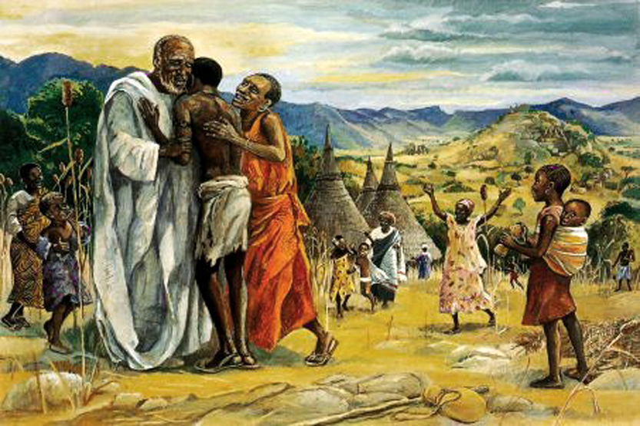
“So he set off and went to his father. But while he was still far off, his father saw him and was filled with compassion; he ran and put his arms around him and kissed him."
(Luke 15:20)

Guests: Mark and Lena
First Free Methodist Church
2625 N. Center Rd.
Saginaw, Michigan 48603
Phone: (989) 799-2930
Email: saginawfmc@gmail.com
www.saginawfirstfmc.org

Fourth Sunday in Lent
March 27, 2022

Prelude
**Greeting/Announcements
*Call to Worship (spoken responsively)
L: The throne of the Lord endures forever
P: My heart overflows with praise to God
L: You love, O Lord, righteousness and despise wickedness
P: Your royal scepter is a scepter of equity
L: We who are in Christ are a new creation
P: We will be instructed in the ways of the Lord
L: Happy are those whose hearts have been made pure
P: The old will pass away, see everything has become new!

*Opening Hymn: “Majesty” #122 (2x)
Majesty, worship His majesty
Unto Jesus, be all glory, honor, and praise
Majesty, kingdom authority
Flow from His throne unto His own, His anthem raise
So exalt, lift up on high, the name of Jesus
Magnify, come glorify, Christ Jesus the King
Majesty, worship His majesty
Jesus who died, now glorified, King of all Kings

*Invocation and Lord’s Prayer
L: Gracious Father, whose blessed Son Jesus the Christ came down from heaven to be the true bread which giveth life to the world; Evermore live us this bread, that he may live in us, and we in him. Remind us how you came to us, entering the chaos of this world, so we may find our way home to you, who continuously looks for the lost. May we find you and your righteousness, as we pray the prayer that Jesus taught His disciples…

P: Our Father, who art in heaven, hallowed be Your name. Your kingdom come; your will be done in earth as it is in heaven. Give us this day our daily bread and forgive us our debts as we forgive our debtors. And lead us not into temptation but deliver us from evil. For Yours is the kingdom, and the power, and the glory forever. Amen.

*Gloria Patri
Glory be to the Father​
And to the Son and to the Holy Ghost.​
As it was in the beginning​
Is now and ever shall be.​
World without end. ​
Amen. Amen.​

First Scripture Lesson: Joshua 5:9-12
The LORD said to Joshua, “Today I have rolled away from you the disgrace of Egypt.”
And so that place is called Gilgal to this day. While the Israelites were camped in Gilgal, they kept the Passover in the evening on the fourteenth day of the month in the plains of Jericho. On the day after the Passover, on that very day, they ate the produce of the land, unleavened cakes and parched grain. The manna ceased on the day they ate the produce of the land, and the Israelites no longer had manna; they ate the crops of the land of Canaan that year.

Prayer of Confession
L: We confess to the Lord so we are reminded of that which is heavenly and that which is earthly. While all things around us pass away, we may hold fast those things which abide forever. May our spirits may grow calm, our vision be clear, and our purpose be unified...

P: On this day and all the days of my life, I entrust to your merciful heart my body and my soul, all my acts, thoughts, choices, desires, words, deeds, my entire life and death. So that, with your assistance, all may be ordered to the good according to the will of your beloved son, our Lord Jesus Christ. Procure for me also, perpetual purity of mind and body, so that with a pure heart and chaste body I may be strengthened to serve you. Obtain for me a spirit of poverty willingly accepted with patience and tranquility of mind, so that I will have the strength to sustain the labors and work of my calling and the salvation of my neighbor. Therefore, may I rejoice in his goodness, sorrow over evils, despise no one, never judge rashly, and never in my heart exalt myself over anyone. Amen.

Affirmation of Faith: Psalm 32
P: Happy are those whose transgression is forgiven, whose sin is covered. Happy are those to whom the LORD imputes no iniquity, and in whose spirit there is no deceit. While I kept silence, my body wasted away through my groaning all day long. For day and night your hand was heavy upon me; my strength was dried up as by the heat of summer. Therefore, let all who are faithful offer prayer to you; at a time of distress, the rush of mighty waters shall not reach them. You are a hiding place for me; you preserve me from trouble; you surround me with glad cries of deliverance. Be glad in the LORD and rejoice, O righteous, and shout for joy, all you upright in heart.

Hymn of Affirmation: “Near the Cross” #240 (vv.1-2,4)
Jesus, keep me near the cross
There a precious fountain
Free to all, a healing stream
Flows from Calv'ry's mountain
In the cross, in the cross
Be my glory ever
Till my ransomed soul shall find
Rest beyond the river

Near the cross a trembling soul
Love and mercy found me
There the bright and morning star
Sheds its beams around me
In the cross, in the cross
Be my glory ever
Till my ransomed soul shall find
Rest beyond the river

Near the cross I’ll watch and wait
Hoping trusting ever
Till I reach the golden strand
Just beyond the river
In the cross, in the cross
Be my glory ever
Till my ransomed soul shall find
Rest beyond the river

Second Scripture Lesson: 2 Corinthians 5:16-21
From now on, therefore, we regard no one from a human point of view; even though we once knew Christ from a human point of view, we know him no longer in that way.
So if anyone is in Christ, there is a new creation: everything old has passed away; see, everything has become new! All this is from God, who reconciled us to himself through Christ, and has given us the ministry of reconciliation; that is, in Christ God was reconciling the world to himself, not counting their trespasses against them, and entrusting the message of reconciliation to us.
So we are ambassadors for Christ, since God is making his appeal through us; we entreat you on behalf of Christ, be reconciled to God. For our sake he made him to be sin who knew no sin, so that in him we might become the righteousness of God.

Special Music: Micki Martin

Children’s Sermon

Passing of the Peace

Prayers of the People
L: Lord in Your Mercy…
P: Hear our prayer.

Gospel Lesson: Luke 15:1-3, 11b-32
Now all the tax collectors and sinners were coming near to listen to him. And the Pharisees and the scribes were grumbling and saying, “This fellow welcomes sinners and eats with them.”
So he told them this parable: “There was a man who had two sons. The younger of them said to his father, ‘Father, give me the share of the property that will belong to me.’ So he divided his property between them. A few days later the younger son gathered all he had and traveled to a distant country, and there he squandered his property in dissolute living.
When he had spent everything, a severe famine took place throughout that country, and he began to be in need. So he went and hired himself out to one of the citizens of that country, who sent him to his fields to feed the pigs. He would gladly have filled himself with the pods that the pigs were eating; and no one gave him anything.
But when he came to himself he said, ‘How many of my father’s hired hands have bread enough and to spare, but here I am dying of hunger! I will get up and go to my father, and I will say to him, “Father, I have sinned against heaven and before you; I am no longer worthy to be called your son; treat me like one of your hired hands.’”
So he set off and went to his father. But while he was still far off, his father saw him and was filled with compassion; he ran and put his arms around him and kissed him. Then the son said to him, ‘Father, I have sinned against heaven and before you; I am no longer worthy to be called your son.’
But the father said to his slaves, ‘Quickly, bring out a robe, the best one, and put it on him; put a ring on his finger and sandals on his feet. And get the fatted calf and kill it, and let us eat and celebrate; for this son of mine was dead and is alive again; he was lost and is found!’ And they began to celebrate.
“Now his elder son was in the field; and when he came and approached the house, he heard music and dancing. He called one of the slaves and asked what was going on. He replied, ‘Your brother has come, and your father has killed the fatted calf, because he has got him back safe and sound.’ Then he became angry and refused to go in. His father came out and began to plead with him.
But he answered his father, ‘Listen! For all these years I have been working like a slave for you, and I have never disobeyed your command; yet you have never given me even a young goat so that I might celebrate with my friends. But when this son of yours came back, who has devoured your property with prostitutes, you killed the fatted calf for him!’
Then the father said to him, ‘Son, you are always with me, and all that is mine is yours. But we had to celebrate and rejoice, because this brother of yours was dead and has come to life; he was lost and has been found.’”

Sermon:

Prayer of Response

Hymn of Response: “What Wondrous Love is This” #245 (vv.1-4)
What wondrous love is this, O my soul, O my soul?
What wondrous love is this, O my soul?
What wondrous love is this that caused the Lord of bliss
To bear the dreadful curse for my soul, for my soul
To bear the dreadful curse for my soul?

When I was sinking down, sinking down, sinking down
When I was sinking down, sinking down
When I was sinking down beneath God’s righteous frown
Christ laid aside his crown for my soul, for my soul
Christ laid aside his crown for my soul

To God and to the Lamb I will sing, I will sing
To God and to the Lamb I will sing
To God and to the Lamb who is the great I Am
While millions join the theme, I will sing, I will sing
While millions join the theme, I will sing

And when from death I’m free I’ll sing on, I’ll sing on
And when from death I’m free, I’ll sing on
And when from death I’m free, I’ll sing and joyful be
And through eternity I’ll sing on, I’ll sing on
And through eternity I’ll sing on

Invitation of Offering
L: Praise be to the God and Father of our Lord Jesus Christ, who sought the lost so that we may become heirs with Christ. Let our worship be an expression of God’s extravagant grace towards us, as we collect this morning’s tithes and offerings.

*Doxology
Praise God, from whom all blessings flow
Praise Him, all creatures here below
Praise Him above, ye heavenly host
Praise Father Son, and Holy Ghost.
Amen.

*Prayer

*Closing Hymn: “You are My Hiding Place” (x2)
You are my hiding place
You always fill my heart
With songs of deliverance
Whenever I am afraid
I will trust in you
I will trust in you
Let the weak say I am strong
In the strength of the Lord

You are my hiding place
You always fill my heart
With songs of deliverance
Whenever I am afraid
I will trust in you
I will trust in you
Let the weak say I am strong
In the strength of the Lord
I will trust in you

*Benediction
L: May the humble power of God carry you. May the tender care of Christ attend you. May the quiet strength of the Holy Spirit sustain you. May the grace of the Trinity indwell you, as you go in peace to love and serve. Amen.

