Saginaw First Free Methodist Church
Fourth Sunday after Pentecost
June 28, 2020
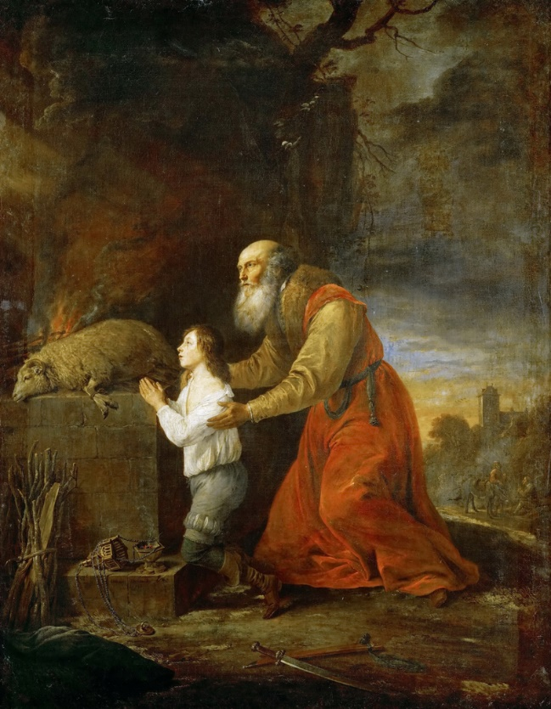
“He said, ‘Do not lay your hand on the boy or do anything to him; for now I know that you fear God, since you have not withheld your son, your only son, from me.’ And Abraham looked up and saw a ram, caught in a thicket by its horns. Abraham went and took the ram and offered it up as a burnt offering instead of his son. So Abraham called that place ‘The LORD will provide’; as it is said to this day, ‘On the mount of the LORD it shall be provided.’” (Genesis 22:12-14)

Minister: Rev. Jason Evans
First Free Methodist Church
2625 N. Center Rd.
Saginaw, Michigan 48603
Phone: (989) 799-2930
Email: saginawfmc@gmail.com
www.saginawfirstfmc.org

Fourth Sunday after Pentecost
June 28, 2020

The mission of Saginaw First Free Methodist Church is to be faithful to God and to make known to all people everywhere God’s call to wholeness in Jesus Christ.

Prelude
Greeting/Announcements
L: We have been led to this time and place to worship
P: We come trusting God’s steadfast love
L: God has made an everlasting covenant with us
P: We often do not understand what God expects from us
L: Let us proclaim God’s faithfulness to all generations
P: Even when we think God has forgotten us
L: God shows us the value of all life and helps us celebrate it
P: May we humble ourselves before the Lord our salvation

*Opening Hymn: “Great Is Thy Faithfulness” #44 (vv.1-3)
Great is Thy faithfulness, O God my Father
There is no shadow of turning with Thee
Thou changest not, Thy compassions, they fail not
As Thou hast been Thou forever wilt be
Great is Thy faithfulness!
Great is Thy faithfulness!
Morning by morning new mercies I see
All I have needed Thy hand hath provided
Great is Thy faithfulness, Lord, unto me!

Summer and winter, and springtime and harvest
Sun, moon, and stars in their courses above
Join with all nature in manifold witness
To Thy great faithfulness, mercy, and love
Great is Thy faithfulness!
Great is Thy faithfulness!
Morning by morning new mercies I see
All I have needed Thy hand hath provided
Great is Thy faithfulness, Lord, unto me!

Pardon for sin and a peace that endureth
Thine own dear presence to cheer and to guide
Strength for today and bright hope for tomorrow
Blessings all mine, with ten thousand beside!
Great is Thy faithfulness!
Great is Thy faithfulness!
Morning by morning new mercies I see
All I have needed Thy hand hath provided
Great is Thy faithfulness, Lord, unto me!

Invocation and Lord’s Prayer
L: We praise your abiding guidance, O God, for you sent us Jesus, our Teacher and Messiah, to model for us the way of love for the whole universe. You invite us to hold the needs of our sisters and brothers, as dear to us as our own needs. Loving our neighbors as ourselves, you broaden the horizon and hope of your people, that they may discover the meaning of your covenant, even in the midst of trial and exile. Increase the number of those who believe in your word, as we pray together the prayer that Jesus taught His disciples…

P: Our Father, who art in heaven, hallowed be Your name. Your kingdom come; your will be done in earth as it is in heaven. Give us this day our daily bread and forgive us our debts as we forgive our debtors. And lead us not into temptation but deliver
us from evil. For Yours is the kingdom, and the power, and the glory forever. Amen.

Gloria Patri
Glory be to the Father​
And to the Son and to the Holy Ghost.​
As it was in the beginning​
Is now and ever shall be.​
World without end. ​
Amen. Amen.​

First Scripture Lesson: Genesis 22:1-14
After these things God tested Abraham. He said to him, “Abraham!” And he said, “Here I am.”

He said, “Take your son, your only son Isaac, whom you love, and go to the land of Moriah, and offer him there as a burnt offering on one of the mountains that I shall show you.”

So Abraham rose early in the morning, saddled his donkey, and took two of his young men with him, and his son Isaac; he cut the wood for the burnt offering, and set out and went to the place in the distance that God had shown him. On the third day Abraham looked up and saw the place far away.

Then Abraham said to his young men, “Stay here with the donkey; the boy and I will go over there; we will worship, and then we will come back to you.”

Abraham took the wood of the burnt offering and laid it on his son Isaac, and he himself carried the fire and the knife. So the two of them walked on together. Isaac said to his father Abraham, “Father!” And he said, “Here I am, my son.” He said, “The fire and the wood are here, but where is the lamb for a burnt offering?”

Abraham said, “God himself will provide the lamb for a burnt offering, my son.” So the two of them walked on together. When they came to the place that God had shown him, Abraham built an altar there and laid the wood in order. He bound his son Isaac, and laid him on the altar, on top of the wood. Then Abraham reached out his hand and took the knife to kill his son.

But the angel of the LORD called to him from heaven, and said, “Abraham, Abraham!” And he said, “Here I am.”

He said, “Do not lay your hand on the boy or do anything to him; for now I know that you fear God, since you have not withheld your son, your only son, from me.”

And Abraham looked up and saw a ram, caught in a thicket by its horns. Abraham went and took the ram and offered it up as a burnt offering instead of his son. So Abraham called that place “The LORD will provide”; as it is said to this day, “On the mount of the LORD it shall be provided.”

Prayer of Confession
L: If God puts us to the test, will God also not provide for us? Are we more willing to trust God or the foolishness of man? Confession is not to weigh us down with guilt, but remind us of God’s love for us. Therefore, let us confess…

P: All merciful God, when we were slaves of sin, we were free in regard to righteousness. What advantage did we then get from the things of which we are and will be ashamed? The end of those things is death. You have made covenant with us, that if we restore your people and creation back to original peace; You will be our God. But we are not often willing to give up our freedom. We only desire for others if we ourselves get a reward of equal value. We obey our passions rather than joining Your intentions of good for all. We value our individualism over the works of building your kingdom. Forgive us for the things we have done, and the things we have left undone. Amen.

Affirmation of Faith: Psalm 13
P: How long, O LORD? Will you forget me forever? How long will you hide your face from me? How long must I bear pain in my soul, and have sorrow in my heart all day long? How long shall my enemy be exalted over me? Consider and answer me, O LORD my God! Give light to my eyes, or I will sleep the sleep of death, and my enemy will say, "I have prevailed"; my foes will rejoice because I am shaken. But I trusted in your steadfast love; my heart shall rejoice in your salvation. I will sing to the LORD, because he has dealt bountifully with me.

*Hymn of Affirmation: “Take My Life, and Let It Be”
Take my life and let it be
Consecrated, Lord, to thee
Take my moments and my days
Let them flow in endless praise
Let them flow in endless praise

Take my hands and let them move
At the impulse of thy love
Take my feet and let them be
Swift and beautiful for thee
Swift and beautiful for thee

Take my will and make it thine
It shall be no longer mine
Take my heart it is thine own
It shall be thy royal throne
It shall be thy royal throne

New Testament Scripture Lesson: Romans 6:1-11
Should we continue in sin in order that grace may abound? By no means! How can we who died to sin go on living in it? Do you not know that all of us who have been baptized into Christ Jesus were baptized into his death? Therefore we have been buried with him by baptism into death, so that, just as Christ was raised from the dead by the glory of the Father, so we too might walk in the newness of life.
For if we have been united with him in a death like his, we will certainly be united with him in a resurrection like his. We know that our old self was crucified with him so that the body of sin might be destroyed, and we might no longer be enslaved to sin. For whoever has died is freed from sin.

But if we have died with Christ, we believe that we will also live with him. We know that Christ, being raised from the dead, will never die again; death no longer has dominion over him. The death he died, he died to sin, once for all; but the life he lives, he lives to God. So you also must consider yourselves dead to sin and alive to God in Christ Jesus.

Special Music: Micki Martin

Passing of the Peace

Prayers of the People
L: Lord in Your Mercy…
P: Hear our prayer.

Gospel Lesson: Matthew 10:24-39
“A disciple is not above the teacher, nor a slave above the master; it is enough for the disciple to be like the teacher, and the slave like the master. If they have called the master of the house Beelzebul, how much more will they malign those of his household!

So have no fear of them; for nothing is covered up that will not be uncovered, and nothing secret that will not become known. What I say to you in the dark, tell in the light; and what you hear whispered, proclaim from the housetops. Do not fear those who kill the body but cannot kill the soul; rather fear him who can destroy both soul and body in hell.

Are not two sparrows sold for a penny? Yet not one of them will fall to the ground apart from your Father. And even the hairs of your head are all counted. So do not be afraid; you are of more value than many sparrows.

Everyone therefore who acknowledges me before others, I also will acknowledge before my Father in heaven; but whoever denies me before others, I also will deny before my Father in heaven. Do not think that I have come to bring peace to the earth; I have not come to bring peace, but a sword.

For I have come to set a man against his father, and a daughter against her mother, and a daughter-in-law against her mother-in-law; and one's foes will be members of one's own household. Whoever loves father or mother more than me is not worthy of me; and whoever loves son or daughter more than me is not worthy of me;

and whoever does not take up the cross and follow me is not worthy of me. Those who find their life will lose it, and those who lose their life for my sake will find it.”

Sermon

Prayer of Response

Hymn of Response: “More Love to Thee”
More love to Thee, oh Christ, more love to Thee!
Hear Thou the prayer I make on bended knee.
This is my earnest plea
More love, oh Christ, to Thee
More love to Thee, more love to Thee!

Once earthly joy I craved, sought peace and rest
Now Thee alone I seek, give what is best.
This all my prayer shall be
More love, oh Christ to Thee
More love to Thee, more love to Thee!

Then shall my latest breath whisper Thy praise
This be the parting cry my heart shall raise
Still all my prayer shall be
More love, oh Christ to Thee
More love to Thee, more love to Thee!
More love to Thee, more love to Thee!

Invitation of Offering
L: God’s provisions are generous and compassionate. God’s will may require our dearest possessions, but the reward is far more valuable. Minister for eternal peace, as we collect this morning’s tithes and offerings.

*Doxology

Prayer

Closing Hymn: “Rise Up, O Church of God”
Rise up, O church of God
Have done with lesser things
Give heart and soul and mind and strength
To serve the King of kings

Rise up, O church of God
From vain ambitions turn
Christ rose triumphant that your hearts
With nobler zeal might burn

Rise up, O church of God
His kingdom’s task embrace
Redress sin’s cruel consequences
Give justice larger place

Lift high the cross of Christ
Tread where His feet have trod
As followers of the Son of Man
Rise up, O church of God

Benediction
L: Our service in Christ’s name will be blessed, so present yourselves for service in the world. Extend Christ’s welcome to neighbors and enemies, honoring all God’s children. Accept the tasks of discipleship, as you go in peace to love and serve. Amen.

