Saginaw First Free Methodist Church
Third Sunday after Pentecost
June 21, 2020
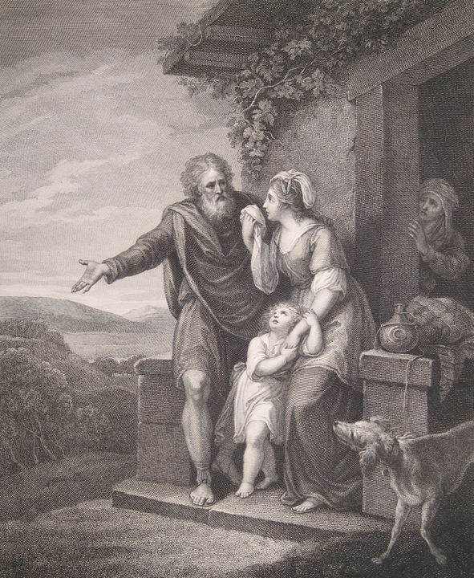
“But Sarah saw the son of Hagar the Egyptian, whom she had borne to Abraham, playing with her son Isaac. So she said to Abraham, ‘Cast out this slave woman with her son; for the son of this slave woman shall not inherit along with my son Isaac.’ The matter was very distressing to Abraham on account of his son.” (Genesis 21:9-11)

Minister: Rev. Jason Evans
First Free Methodist Church
2625 N. Center Rd.
Saginaw, Michigan 48603
Phone: (989) 799-2930
Email: saginawfmc@gmail.com
www.saginawfirstfmc.org

Third Sunday after Pentecost
June 21, 2020

The mission of Saginaw First Free Methodist Church is to be faithful to God and to make known to all people everywhere God’s call to wholeness in Jesus Christ.

Prelude
Greeting/Announcements
L: God in Christ has reconciled all races and people together
P: We are humbled by the wonders of all God’s creations
L: This infinite God cares for every one of us
P: We celebrate the diversity of God’s Holy Kingdom
L: In days of trouble, all people can call on God for advocacy
P: Our God listens and cares for all people
L: We call on God with our prayers of faith
P: We care for those the world uses and rejects

*Opening Hymn: “Come, Ye Faithful, Raise the Strain”

Come, ye faithful, raise the strain
Of triumphant gladness
God hath brought his Israel
Into joy from sadness
Loosed from Pharaoh's bitter yoke
Jacob's sons and daughters
Led them with unmoistened foot
Through the Red Sea waters

'Tis the spring of souls today
Christ hath burst his prison
and from three days' sleep in death
as a sun hath risen
all the winter of our sins
long and dark, is flying
from his light, to whom we give
laud and praise undying

"Alleuia!" now we cry
To our King immortal
Who, triumphant, burst the bars
Of the tomb's dark portal
"Alleluia!" with the Son
God the Father praising
"Alleluia!" yet again
To the Spirit raising

Invocation and Lord’s Prayer
L: God of creation, we are weary of conflict and long for peace to happen on earth. You have given the Holy Spirit to empower us to make disciples of those living in chaos. We celebrate the comfort and advocacy that is left with us. We need to participate with the Holy Spirit in caring for others. Send your light that we can proclaim the gospel, and as we pray together the prayer that Jesus taught His disciples…

P: Our Father, who art in heaven, hallowed be Your name. Your kingdom come; your will be done in earth as it is in heaven. Give us this day our daily bread and forgive us our debts as we forgive our debtors. And lead us not into temptation but deliver
us from evil. For Yours is the kingdom, and the power, and the glory forever. Amen.

Gloria Patri

First Scripture Lesson: Genesis 21:8-21

The child grew, and was weaned; and Abraham made a great feast on the day that Isaac was weaned. But Sarah saw the son of Hagar the Egyptian, whom she had borne to Abraham, playing with her son Isaac. So she said to Abraham, “Cast out this slave woman with her son; for the son of this slave woman shall not inherit along with my son Isaac.”

The matter was very distressing to Abraham on account of his son. But God said to Abraham, “Do not be distressed because of the boy and because of your slave woman; whatever Sarah says to you, do as she tells you, for it is through Isaac that offspring shall be named for you. As for the son of the slave woman, I will make a nation of him also, because he is your offspring.”

So Abraham rose early in the morning, and took bread and a skin of water, and gave it to Hagar, putting it on her shoulder, along with the child, and sent her away. And she departed, and wandered about in the wilderness of Beer-sheba. When the water in the skin was gone, she cast the child under one of the bushes.

Then she went and sat down opposite him a good way off, about the distance of a bowshot; for she said, “Do not let me look on the death of the child.” And as she sat opposite him, she lifted up her voice and wept.

And God heard the voice of the boy; and the angel of God called to Hagar from heaven, and said to her, “What troubles you, Hagar? Do not be afraid; for God has heard the voice of the boy where he is. Come, lift up the boy and hold him fast with your hand, for I will make a great nation of him.”

Then God opened her eyes and she saw a well of water. She went, and filled the skin with water, and gave the boy a drink. God was with the boy, and he grew up; he lived in the wilderness, and became an expert with the bow. He lived in the wilderness of Paran; and his mother got a wife for him from the land of Egypt.

Prayer of Confession
L: We are confident that God hears and answers our prayers. But are we persistent in praying for our enemies? We know God cares for us, but does that satisfy us? Or do we advocate for the care of all mistreated people? For our times of disunity, let us confess…

P: Almighty God, who created all things good, we read that in spite of Sarah’s jealousy, You care for and love those who are cast out. Our world calls for peace, but instead of unifying, we continue to cast out and deny those stamped with the image of God. We use rules and laws to justify segregation and mistreatment of those we oppress, while denying culpability and passing the blame. Like Sarah, we are jealous when others receive good fortune, and we wish to be superior to them. We leverage our power and influence to convince others to participate and act unjustly. Teach us to be dead from sin and to share the goodness you provide all creatures. Amen.

Affirmation of Faith: Psalm 86
P: Incline your ear, O LORD, and answer me, for I am poor and needy. Preserve my life, for I am devoted to you; save your servant who trusts in you. You are my God; be gracious to me, O Lord, for to you do I cry all day long. Gladden the soul of your servant, for to you, O Lord, I lift up my soul. For you, O Lord, are good and forgiving, abounding in steadfast love to all who call on you. Give ear, O LORD, to my prayer; listen to my cry of supplication. In the day of my trouble I call on you, for you will answer me. There is none like you among the gods, O Lord, nor are there any works like yours. All the nations you have made shall come and bow down before you, O Lord, and shall glorify your name. For you are great and do wondrous things; you alone are God. Turn to me and be gracious to me; give your strength to your servant; save the child of your serving girl. Show me a sign of your favor, so that those who hate me may see it and be put to shame, because you, LORD, have helped me and comforted me.

*Hymn of Affirmation: “I Surrender All”
All to Jesus I surrender
All to Him I freely give
I will ever love and trust Him
In His presence daily live
I surrender all, I surrender all
All to Thee, my blessed Savior
I surrender all

All to Jesus I surrender
Humbly at His feet I bow
Worldly pleasures all forsaken
Take me, Jesus, take me now
I surrender all, I surrender all
All to Thee, my blessed Savior
I surrender all

All to Jesus I surrender
Lord, I give myself to Thee
Fill me with Thy love and power
Let Thy blessing fall on me
I surrender all, I surrender all
All to Thee, my blessed Savior
I surrender all

New Testament Scripture Lesson: Romans 6:12-23

Therefore, do not let sin exercise dominion in your mortal bodies, to make you obey their passions. No longer present your members to sin as instruments of wickedness, but present yourselves to God as those who have been brought from death to life, and present your members to God as instruments of righteousness. For sin will have no dominion over you, since you are not under law but under grace.

What then? Should we sin because we are not under law but under grace? By no means! Do you not know that if you present yourselves to anyone as obedient slaves, you are slaves of the one whom you obey, either of sin, which leads to death, or of obedience, which leads to righteousness?

But thanks be to God that you, having once been slaves of sin, have become obedient from the heart to the form of teaching to which you were entrusted, and that you, having been set free from sin, have become slaves of righteousness. I am speaking in human terms because of your natural limitations. For just as you once presented your members as slaves to impurity and to greater and greater iniquity, so now present your members as slaves to righteousness for sanctification.

When you were slaves of sin, you were free in regard to righteousness. So what advantage did you then get from the things of which you now are ashamed? The end of those things is death. But now that you have been freed from sin and enslaved to God, the advantage you get is sanctification. The end is eternal life.

For the wages of sin is death, but the free gift of God is eternal life in Christ Jesus our Lord.

Special Music: Micki Martin

Passing of the Peace

Prayers of the People
L: Lord in Your Mercy…
P: Hear our prayer.

Gospel Lesson: Matthew 10:40-42

“Whoever welcomes you welcomes me, and whoever welcomes me welcomes the one who sent me. Whoever welcomes a prophet in the name of a prophet will receive a prophet's reward; and whoever welcomes a righteous person in the name of a righteous person will receive the reward of the righteous; and whoever gives even a cup of cold water to one of these little ones in the name of a disciple -- truly I tell you, none of these will lose their reward.”

Sermon

Prayer of Response

Hymn of Response: “Rescue the Perishing”
Rescue the perishing, care for the dying
Snatch them in pity from sin and the grave
Weep o'er the erring one, lift up the fallen
Tell them of Jesus, the mighty to save
Rescue the perishing, care for the dying
Jesus is merciful, Jesus will save

Down in the human heart, crushed by the tempter
Feelings lie buried that grace can restore
Touched by a loving heart, wakened by kindness
Chords that are broken will vibrate once more
Rescue the perishing, care for the dying
Jesus is merciful, Jesus will save

Rescue the perishing, duty demands it
Strength for thy labor the Lord will provide
Back to the narrow way patiently win them
Tell the poor wanderer a Savior has died
Rescue the perishing, care for the dying
Jesus is merciful, Jesus will save

Invitation of Offering
L: We have received abundant life; what value does the riches of this world hold? We have received care and advocacy from the Almighty Creator, we can share that with others. Give to the world God so loves, as we collect this morning’s tithes and offerings.

*Doxology

Prayer

Closing Hymn: “Love Lifted Me”
I was sinking deep in sin
Far from the peaceful shore
Very deeply stained within
Sinking to rise no more
But the Master of the sea
Heard my despairing cry
From the waters lifted me
Now safe am I
Love lifted me!
Love lifted me!
When nothing else could help,
Love lifted me.
Love lifted me!
Love lifted me!
When nothing else could help,
Love lifted me

Souls in danger, look above
Jesus completely saves
He will lift you by his love
Out of the angry waves
He’s the Master of the sea
Billows his will obey
He your Savior wants to be
Be saved today
Love lifted me!
Love lifted me!
When nothing else could help,
Love lifted me.
Love lifted me!
Love lifted me!
When nothing else could help,
Love lifted me

Benediction
L: God has shown love and care for those we wouldn’t expect. We are united with Christ in his death. Let the world see your acts of unity, not division. Do not fear or be jealous, but let your compassion be seen by all, as you go in peace to love and serve. Amen.

