First Free Methodist Church of Saginaw
Sixth Sunday after Pentecost
July 17, 2022

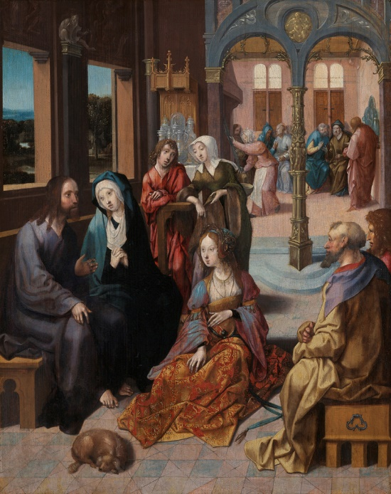
“’There is need of only one thing. Mary has chosen the better part, which will not be taken away from her.’"
(Luke 10:42)

Minister: Rev. Jason Evans
First Free Methodist Church
2625 N. Center Rd.
Saginaw, Michigan 48603
Phone: (989) 799-2930
Email: saginawfmc@gmail.com
www.saginawfirstfmc.org

PROPER 11 (16)
July 17, 2022

Prelude
**Greeting/Announcements
*Call to Worship (spoken responsively)
L: O LORD, who may abide in your tent?
P: Those who walk blamelessly, and do what is right
L: Who do not take up a reproach against their neighbors
P: Who do not lend money at interest
L: O LORD, who may dwell on your holy hill?
P: Those who speak the truth from their heart
L: Who stand by their oath even to their hurt
P: Those who do not slander with their tongue
L: Those who do these things shall never be moved
P: Your love never fails

*Opening Hymn: “His Name is Wonderful” #149 (vv.1-2)
His Name is Wonderful, His Name is Wonderful
His Name is Wonderful, Jesus my Lord
He’s the Great Shepherd, The Rock of all Ages
Almighty God is He
Bow down before Him, Love and adore Him
His Name is Wonderful, Jesus my Lord

He is the mighty King, Master of everything
His Name is Wonderful, Jesus my Lord
He’s the Great Shepherd, The Rock of all Ages
Almighty God is He
Bow down before Him, Love and adore Him
His Name is Wonderful, Jesus my Lord

*Invocation and Lord’s Prayer
L: Almighty God, the fountain of all wisdom, who knows our necessities before we ask and our ignorance in asking: Have compassion, we beg you, upon our infirmities, and those things which for our unworthiness we dare not, and for our blindness we cannot ask, mercifully give us for the worthiness of your Son Christ Jesus our Lord. Reveal your mysteries to us, as we pray the prayer that Jesus taught His disciples…

P: Our Father, who art in heaven, hallowed be Your name. Your kingdom come; your will be done in earth as it is in heaven. Give us this day our daily bread and forgive us our debts as we forgive our debtors. And lead us not into temptation but deliver us from evil. For Yours is the kingdom, and the power, and the glory forever. Amen.

*Gloria Patri
Glory be to the Father​
And to the Son and to the Holy Ghost.​
As it was in the beginning​
Is now and ever shall be.​
World without end. ​
Amen. Amen.​

First Scripture Lesson: Amos 8:1-12
This is what the Lord GOD showed me, a basket of summer fruit. He said, “Amos, what do you see?” And I said, “A basket of summer fruit.”
Then the LORD said to me, “The end has come upon my people Israel; I will never again pass them by. The songs of the temple shall become wailings in that day,” says the Lord GOD; “the dead bodies shall be many, cast out in every place. Be silent!”
Hear this, you that trample on the needy, and bring to ruin the poor of the land, saying, “When will the new moon be over so that we may sell grain; and the sabbath, so that we may offer wheat for sale? We will make the ephah small and the shekel great, and practice deceit with false balances, buying the poor for silver and the needy for a pair of sandals, and selling the sweepings of the wheat.”
The LORD has sworn by the pride of Jacob: Surely I will never forget any of their deeds. Shall not the land tremble on this account, and everyone mourn who lives in it, and all of it rise like the Nile, and be tossed about and sink again, like the Nile of Egypt? On that day, says the Lord GOD, I will make the sun go down at noon, and darken the earth in broad daylight.
I will turn your feasts into mourning, and all your songs into lamentation; I will bring sackcloth on all loins, and baldness on every head; I will make it like the mourning for an only son, and the end of it like a bitter day. The time is surely coming, says the Lord GOD, when I will send a famine on the land; not a famine of bread, or a thirst for water, but of hearing the words of the LORD. They shall wander from sea to sea, and from north to east; they shall run to and fro, seeking the word of the LORD, but they shall not find it.”

Prayer of Confession
L: Lord, by your grace, enlighten our understanding, strengthen our will, purify our hearts, and make us holy...

P: Although I am dust and ashes, Lord, I am tied to you by the bonds of love. Therefore, I feel I can speak freely to you. Before I came to know you, I was nothing. I did not know the meaning of life, and I had no understanding of myself. I have no doubt that you had a purpose in causing me to be born; yet you had no need of me, and on my own I was of no use to you. But then you decided that I should hear the worlds of Your Son, Jesus Christ. And that as I heard his words, you enabled his love to penetrate my heart. Now I am completely saturated in his love and faith, and there is no remedy. Now, Lord, I cannot change my attitude to my faith; I can only die for it. Amen.

Affirmation of Faith: Psalm 52
P: Why do you boast, O mighty one, of mischief done against the godly? All day long you are plotting destruction. Your tongue is like a sharp razor, you worker of treachery. You love evil more than good, and lying more than speaking the truth. You love all words that devour, O deceitful tongue. The righteous will see, and fear, and will laugh at the evildoer, saying, “See the one who would not take refuge in God, but trusted in abundant riches, and sought refuge in wealth!” But I am like a green olive tree in the house of God. I trust in the steadfast love of God forever and ever. I will thank you forever, because of what you have done. In the presence of the faithful I will proclaim your name, for it is good.

Hymn of Affirmation: “In the Cross of Christ I Glory” #234 (vv.1-4)
In the cross of Christ I glory
Towering o’er the wrecks of time
All the light of sacred story
Gathers round its head sublime

When the woes of life o’ertake me
Hopes deceive, and fears annoy
Never shall the cross forsake me
Lo! it glows with peace and joy

When the sun of bliss is beaming
Light and love upon my way
From the cross the radiance streaming
Adds more luster to the day

Bane and blessing, pain and pleasure
By the cross are sanctified
Peace is there that knows no measure
Joys that through all time abide

Second Scripture Lesson: Colossians 1:15-28
He is the image of the invisible God, the firstborn of all creation; for in him all things in heaven and on earth were created, things visible and invisible, whether thrones or dominions or rulers or powers--all things have been created through him and for him.
He himself is before all things, and in him all things hold together. He is the head of the body, the church; he is the beginning, the firstborn from the dead, so that he might come to have first place in everything. For in him all the fullness of God was pleased to dwell, and through him God was pleased to reconcile to himself all things, whether on earth or in heaven, by making peace through the blood of his cross.
And you who were once estranged and hostile in mind, doing evil deeds, he has now reconciled in his fleshly body through death, so as to present you holy and blameless and irreproachable before him, provided that you continue securely established and steadfast in the faith, without shifting from the hope promised by the gospel that you heard, which has been proclaimed to every creature under heaven. I, Paul, became a servant of this gospel.
I am now rejoicing in my sufferings for your sake, and in my flesh, I am completing what is lacking in Christ's afflictions for the sake of his body, that is, the church. I became its servant according to God’s commission that was given to me for you, to make the word of God fully known, the mystery that has been hidden throughout the ages and generations but has now been revealed to his saints.
To them God chose to make known how great among the Gentiles are the riches of the glory of this mystery, which is Christ in you, the hope of glory. It is he whom we proclaim, warning everyone and teaching everyone in all wisdom, so that we may present everyone mature in Christ.

Children’s Sermon

Passing of the Peace

Prayers of the People
L: Lord in Your Mercy…
P: Hear our prayer.

Gospel Lesson: Luke 10:38-42
Now as they went on their way, he entered a certain village, where a woman named Martha welcomed him into her home. She had a sister named Mary, who sat at the Lord’s feet and listened to what he was saying.
But Martha was distracted by her many tasks; so she came to him and asked, “Lord, do you not care that my sister has left me to do all the work by myself? Tell her then to help me.”
But the Lord answered her, “Martha, Martha, you are worried and distracted by many things; there is need of only one thing. Mary has chosen the better part, which will not be taken away from her.”

Sermon: “Joy In the Face of God”

Prayer of Response

Hymn of Response: “What a Friend We Have in Jesus” #625 (vv.1-3)
What a friend we have in Jesus
All our sins and griefs to bear
What a privilege to carry
Everything to God in prayer
Oh, what peace we often forfeit
Oh, what needless pain we bear
All because we do not carry
Everything to God in prayer

Have we trials and temptations?
Is there trouble anywhere?
We should never be discouraged
Take it to the Lord in prayer
Can we find a friend so faithful
Who will all our sorrows share?
Jesus knows our every weakness
Take it to the Lord in prayer

Are we weak and heavy laden
Cumbered with a load of care?
Precious Savior, still our refuge
Take it to the Lord in prayer
Do thy friends despise, forsake thee?
Take it to the Lord in prayer
In His arms he’ll take and shield thee
Thou wilt find a solace there

Invitation of Offering
L: Each of you must give as you have made up your mind. Give as the Lord has given you. ‘Open your hand to the poor and needy neighbor in your land.’ Give joyfully, as we collect this morning’s tithes and offerings.

*Doxology
Praise God, from whom all blessings flow
Praise Him, all creatures here below
Praise Him above, ye heavenly host
Praise Father Son, and Holy Ghost.
Amen.

*Prayer

*Closing Hymn: “At the Name of Jesus” #277 (vv.1,3-4)
At the name of Jesus ev'ry knee shall bow
Ev'ry tongue confess him King of glory now
'Tis the Father's pleasure we should call him Lord
Who from the beginning was the mighty Word

In your hearts enthrone him; there let him subdue
All that is not holy, all that is not true
Crown him as your Captain in temptation's hour
Let his will enfold you in its light and pow'r

Watch, for this Lord Jesus shall return again
With his Father’s glory o’er the earth to reign
Fro the day is coming when each knee shall bow
All our hearts confess Him King of Glory now

*Benediction
L: Go into your week as a disciple of Jesus the Christ. May the perfect love of God be in your heart. May the eternal salvation of Christ be in your heart. May the faithful empowerment of the Spirit be your guide, as you go in peace to love and serve. Amen.

