First Free Methodist Church of Saginaw
Seventh Sunday after Pentecost
July 16, 2023

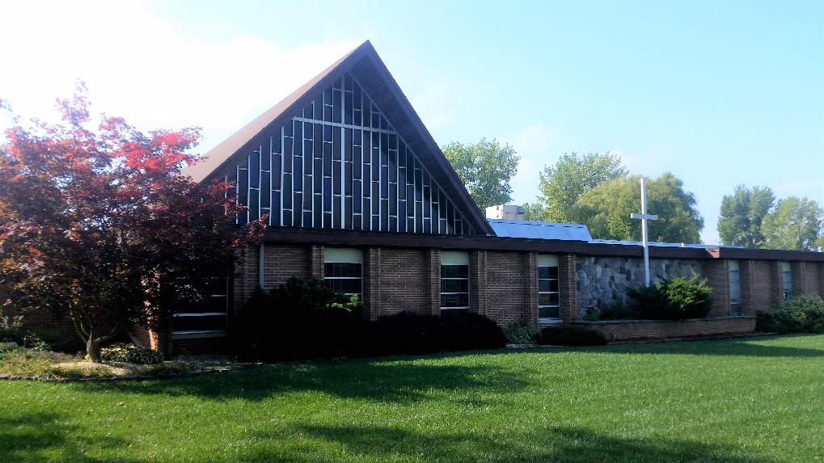
“Other seeds fell on good soil and brought forth grain, some a hundredfold, some sixty, some thirty.”
(Matthew 13:8)

Minister: Rev. Jason Evans
First Free Methodist Church
2625 N. Center Rd.
Saginaw, Michigan 48603
Phone: (989) 799-2930
Email: saginawfmc@gmail.com
www.saginawfirstfmc.org

Seventh Sunday after Pentecost
July 16, 2023

Prelude
Announcements

*Call to Worship (spoken responsively)
L: Give thanks to the Lord
P: For great is the glory of the LORD
L: We will sing of the ways of God
P: We give thanks for your steadfast love and your faithfulness
L: The LORD will give what is good
P: Restore us again, O God of our salvation
L: Salvation is at hand for those who fear him
P: Let me hear what the LORD God will speak

*Opening Song: “Here I Am to Worship”
Light of the world
You stepped down into darkness
Opened my eyes and let me see
Beauty that made this heart adore You
Hope of a life spent with You

Here I am to worship, here I am to bow down
Here I am to say that You're my God
Altogether lovely, altogether worthy
Altogether wonderful to me

King of all days, oh so highly exalted
You're glorious in heaven above, yes You are
Humbly You came to this Earth You created
All for love's sake became poor

Here I am to worship, here I am to bow down
Here I am to say that You're my God
Altogether lovely, altogether worthy
Altogether wonderful to me

I'll never know how much it cost
To see my sin up on that cross
I'll never know how much it cost
To see my sin up on that cross

Here I am to worship, here I am to bow down
Here I am to say that You're my God
Altogether lovely, altogether worthy
Altogether wonderful to me

*Invocation and Lord’s Prayer
L: O God, protector of all that trust in you, without whom nothing is strong, nothing is holy; Increase and multiply on us your mercy, that, through being our ruler and guide, we may so pass through things that are temporal, so we shall never lose the things that are eternal. Fill each heart with love for you and neighbor, that we may minister, full of your grace and mercy, as we pray the prayer that Jesus taught His disciples…

P: Our Father, who art in heaven, hallowed be Your name. Your kingdom come; your will be done in earth as it is in heaven. Give us this day our daily bread and forgive us our debts as we forgive our debtors. And lead us not into temptation but deliver us from evil. For Yours is the kingdom, and the power, and the glory forever. Amen.

*Gloria Patri
Glory be to the Father​
And to the Son and to the Holy Ghost​
As it was in the beginning​
Is now and ever shall be
World without end
Amen. Amen.​

Passing of the Peace

Congregational Song: “Hallelujah! What a Savior!” #253 (vv.1,3,5)
Man of sorrows what a name
For the Son of God, who came
Ruined sinners to reclaim
Hallelujah, what a Savior

Guilty, vile, and helpless we
Spot-less Lamb of God was He
Full atonement, can it be?
Hallelujah, what a Savior

When he comes, our glorious King
All his ransomed home to bring
Then anew this song we'll sing
Hallelujah, what a Savior

Congregational Reading:
P: O God, early in the morning I cry to you. Help me to pray and to concentrate my thoughts on you. I cannot do this alone. In me there is darkness, but with you there is light. I am lonely, but you do not leave me. I am feeble in heart, but with you there is help. I am restless, but with you there is peace. In me there is bitterness, but with you there is patience. I do not understand your ways, but you know the way for me. Restore me to liberty, and enable me so to live now that I may answer before you and before me. Lord, whatever this day may bring, your name be praised. Amen.

Communion
MINISTER: THE INVITATION
You who truly and earnestly repent of your sins, who live in love and peace with
your neighbors and who intend to lead a new life, following the commandments
of God and walking in His holy ways, draw near with faith, and take this holy
sacrament to your comfort; and humbly kneeling, make your honest confession
to Almighty God.

IN UNISON: THE GENERAL CONFESSION
Almighty God, Father of our Lord Jesus Christ, maker of all things, judge of all
people, we confess that we have sinned, and we are deeply grieved as we
remember the wickedness of our past lives. We have sinned against You, Your
holiness and Your love, and we deserve only Your indignation and anger.
We sincerely repent, and we are genuinely sorry for all wrongdoing and every
failure to do the things we should. Our hearts are grieved, and we acknowledge
that we are hopeless without Your grace.
Have mercy upon us.
Have mercy upon us, most merciful Father, for the sake of your son, our Savior, Jesus
Christ, who died for us.
Forgive us.
Cleanse us.
Give us strength to serve and please You in newness of life and to honor and praise
Your name, through Jesus Christ our Lord. Amen.

MINISTER: THE AFFIRMATION OF FAITH
O Almighty God, our Heavenly Father, who with great mercy has promised
forgiveness to all who turn to You with hearty repentance and true faith, have
mercy upon us, pardon and deliver us from our sins, make us strong and faithful in
all goodness and bring us to everlasting life, through Jesus Christ our Lord. Amen.

CONGREGATION: THE COLLECT
Almighty God, unto whom all hearts are open, all desires known, and from whom
no secrets are hid: cleanse the thoughts of our hearts, by the inspiration of the
Holy Spirit, that we may perfectly love You and worthily magnify Your holy name,
through Christ our Lord. Amen.

MINISTER: THE SANCTUS
It is always right and proper, and our moral duty, that we should at all times and
in all places give thanks to You, O Lord, holy Father, Almighty and Everlasting God.
Therefore, with angels and archangels, and with all the inhabitants of heaven, we
honor and adore Your glorious name, evermore praising You and saying,

CONGREGATION: THE SANCTUS (CONTINUED)
Holy, Holy, Holy, Lord God of hosts!
Heaven and earth are full of Thy glory.
Glory be to Thee, O Lord, most high. Amen

MINISTER: THE PRAYER FOR SPIRITUAL COMMUNION
We do not come to this Your table, O merciful Lord, with self-confidence and
pride, trusting in our own righteousness, but we trust in Your great and many
mercies. We are not worthy to gather the crumbs from under Your table. But You,
O Lord, are unchanging in Your mercy and Your nature is love; grant us, therefore,
God of mercy, God of grace, so to eat at this Your table that we may receive in
spirit and in truth the body of Your dear Son, Jesus Christ, and the merits of His
shed blood, so that we may live and grow in His likeness and, being washed and
cleansed through His most precious blood, we may evermore live in Him and He
in us. Amen.

MINISTER: THE PRAYER OF CONSECRATION OF THE ELEMENTS
Almighty God, our Heavenly Father, who gave in love Your only Son, Jesus Christ,
to suffer death upon the cross for our redemption, who by His sacrifice, offered
once for all, did provide a full, perfect, and sufficient atonement for the sins of the whole world,
we come now to Your table in obedience to Your Son, Jesus Christ, who in His holy gospel
commanded us to continue a perpetual memory of His precious death until He comes
again. Hear us, O merciful Father, we humbly ask, and grant that we, receiving this bread and this cup,
as He commanded and in the memory of His passion and death, may partake of His most blessed body and blood.

In the night of His betrayal, Jesus took bread, and when He had given thanks, He broke it and gave it to
His disciples, saying, “Take, eat; this is My body which is given for you; do this in remembrance of Me.”

In like manner, after supper He took the cup, and when He had given thanks, He gave it to them, saying, “Drink of
this, all of you, for this is My blood of the New Testament, which is shed for you and for many, for the remission of
sins; do this as often as you drink it, in remembrance of Me.” Amen.

The body of our Lord Jesus Christ, which was given for you, preserve your soul and body unto everlasting
life. Take and eat this in remembrance that Christ died for you, and feed upon Him in your heart, by faith with
thanksgiving.

The blood of our Lord Jesus Christ, which was shed for you, preserve your soul and body unto everlasting life.
Drink this in remembrance that Christ’s blood was shed for you and be thankful.

MINISTER: THE BENEDICTION
May the peace of God, which passes all understanding, keep your hearts and minds in the knowledge and love
of God, and of His Son, Jesus Christ our Lord; and may the blessing of God Almighty, the Father, the Son, and
the Holy Spirit, be yours now and forever. Amen.

Children’s Sermon

Gospel Lesson: Matthew 13:1-9, 18-23
That same day Jesus went out of the house and sat beside the sea. Such great crowds gathered around him that he got into a boat and sat there, while the whole crowd stood on the beach. And he told them many things in parables, saying: “Listen! A sower went out to sow. And as he sowed, some seeds fell on the path, and the birds came and ate them up. Other seeds fell on rocky ground, where they did not have much soil, and they sprang up quickly, since they had no depth of soil. But when the sun rose, they were scorched; and since they had no root, they withered away. Other seeds fell among thorns, and the thorns grew up and choked them. Other seeds fell on good soil and brought forth grain, some a hundredfold, some sixty, some thirty. Let anyone with ears listen!”
“Hear then the parable of the sower. When anyone hears the word of the kingdom and does not understand it, the evil one comes and snatches away what is sown in the heart; this is what was sown on the path. As for what was sown on rocky ground, this is the one who hears the word and immediately receives it with joy; yet such a person has no root, but endures only for a while, and when trouble or persecution arises on account of the word, that person immediately falls away. As for what was sown among thorns, this is the one who hears the word, but the cares of the world and the lure of wealth choke the word, and it yields nothing. But as for what was sown on good soil, this is the one who hears the word and understands it, who indeed bears fruit and yields, in one case a hundredfold, in another sixty, and in another thirty.”

Sermon: “Finding Good Soil”

Prayers of the People
L: Lord in Your Mercy…
P: Hear our prayer.

Hymn of Response: “Wonderful Grace of Jesus” #360 (vv.1-3)
Wonderful grace of Jesus,
Greater than all my sin;
How shall my tongue describe it,
Where shall its praise begin?
Taking away my burden,
Setting my spirit free;
For the wonderful grace of Jesus reaches me.
Wonderful the matchless grace of Jesus,
Deeper than the mighty rolling sea;
Higher than the mountain, sparkling like a fountain,
All-sufficient grace for even me!
Broader than the scope of my transgressions,
Greater far than all my sin and shame;
Oh, magnify the precious Name of Jesus,
Praise His Name!

Wonderful grace of Jesus,
Reaching to all the lost,
By it I have been pardoned,
Saved to the uttermost;
Chains have been torn asunder,
Giving me liberty;
For the wonderful grace of Jesus reaches me.
Wonderful the matchless grace of Jesus,
Deeper than the mighty rolling sea;
Higher than the mountain, sparkling like a fountain,
All-sufficient grace for even me!
Broader than the scope of my transgressions,
Greater far than all my sin and shame;
Oh, magnify the precious Name of Jesus,
Praise His Name!

Wonderful grace of Jesus
Reaching the most reviled
By its transforming power
Making me God’s dear child
Purchasing peace and heaven
For all eternity
For the wonderful grace of Jesus reaches me
Wonderful the matchless grace of Jesus,
Deeper than the mighty rolling sea;
Higher than the mountain, sparkling like a fountain,
All-sufficient grace for even me!
Broader than the scope of my transgressions,
Greater far than all my sin and shame;
Oh, magnify the precious Name of Jesus,
Praise His Name!

Invitation of Offering
L: Where your treasure is, there your heart will be also. Do not store up for yourselves treasures on earth. Store up an eternal inheritance. Serve the God of light, as we collect this morning’s tithes and offerings.

*Doxology

*Prayer

*Closing Hymn: “Thy Word” (vv.1-2)
Thy word is a lamp unto my feet
And a light unto my path
Thy word is a lamp unto my feet
And a light unto my path

When I feel afraid,
And think I've lost my way
Still, you're there right beside me
Nothing will I fear
As long as you are near
Please be near me to the end

Thy word is a lamp unto my feet
And a light unto my path
Thy word is a lamp unto my feet
And a light unto my path
I will not forget
Your love for me and yet
My heart forever is wandering
Jesus by my guide
And hold me to your side
And I will love you to the end

Thy word is a lamp unto my feet
And a light unto my path
Thy word is a lamp unto my feet
And a light unto my path

*Benediction
L: The Lord bless you and keep you. The Lord make his face to shine on you and be gracious to you. The Lord turn his face towards you and give you peace. Take this blessing, as you go in peace to love and serve. Amen.

