First Free Methodist Church of Saginaw
4th Sunday After Epiphany
January 29, 2023

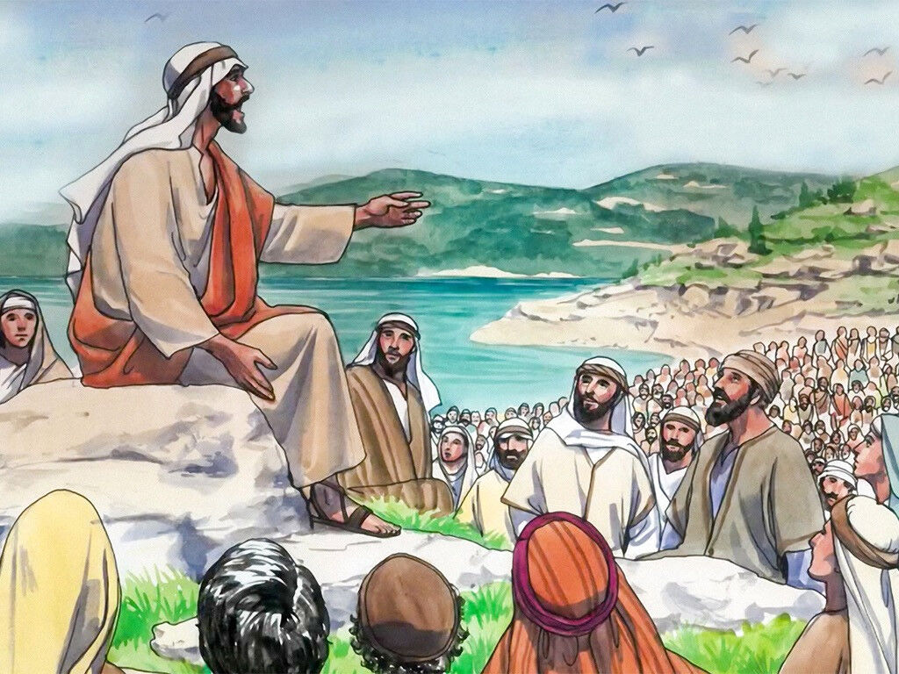
“Blessed are the pure in heart, for they will see God." (Matthew 5:8)

Minister: Rev. Jason Evans
First Free Methodist Church
2625 N. Center Rd.
Saginaw, Michigan 48603
Phone: (989) 799-2930
Email: saginawfmc@gmail.com
www.saginawfirstfmc.org

4th Sunday After Epiphany
January 29, 2023

Prelude
Greeting/Announcements
*Call to Worship (spoken responsively)
L: The Lord draws all nations into God’s courts
P: God is our rock and our fortress
L: Jesus was anointed to preach good news to the poor
P: The Spirit of the Lord was upon him
L: To the prisoner and the oppressed
P: It was a year of jubilee
L: To the sick and the blind
P: It is a year of the Lord’s favor

*Opening Hymn: “Brightest and Best of the Sons of the Morning” (vv.1-4)
Brightest and best of the sons of the morning
Dawn on our darkness and lend us your aid
Star of the east, the horizon adorning
Guide where our infant Redeemer is laid

Cold on his cradle the dewdrops are shining
Low lies his head with the beasts of the stall
Angels adore him in slumber reclining
Maker and monarch and Savior of all

Say shall we yield him in costly devotion
Odors of Edom and offerings divine
Gems of the mountain and pearls of the ocean
Myrrh from the forest and gold from the mine

Vainly we offer each ample oblation
Vainly with gifts would his favor secure
Richer by far is the heart's adoration
Dearer to God are the prayers of the poor

*Passing of the Peace

*Invocation and Lord’s Prayer
L: O God, you spoke your word and revealed your good news in Jesus, the Christ. Fill all creation with that word again, so that by proclaiming your joyful promises to all nations and singing of your glorious hope to all peoples, we may become one living body, your incarnate presence on the earth. And now, our God, we give thanks to you and praise your glorious name, as we pray the prayer that Jesus taught His disciples…

P: Our Father, who art in heaven, hallowed be Your name. Your kingdom come; your will be done in earth as it is in heaven. Give us this day our daily bread and forgive us our debts as we forgive our debtors. And lead us not into temptation but deliver us from evil. For Yours is the kingdom, and the power, and the glory forever. Amen.

*Gloria Patri
Glory be to the Father​
And to the Son and to the Holy Ghost
As it was in the beginning​
Is now and ever shall be
World without end
Amen. Amen.​

Congregational Reading: Psalm 15
P: O LORD, who may abide in your tent? Who may dwell on your holy hill? Those who walk blamelessly, and do what is right, and speak the truth from their heart; who do not slander with their tongue, and do no evil to their friends, nor take up a reproach against their neighbors; in whose eyes the wicked are despised, but who honor those who fear the LORD; who stand by their oath even to their hurt; who do not lend money at interest, and do not take a bribe against the innocent. Those who do these things shall never be moved.

Congregational Hymn: “When I Survey the Wondrous Cross” #239 (vv.1-4)
When I survey the wondrous cross
On which the Prince of glory died
My richest gain I count but loss
And pour contempt on all my pride

Forbid it, Lord, that I should boast
Save in the death of Christ, my God!
All the vain things that charm me most
I sacrifice them to his blood

See, from his head, his hands, his feet
Sorrow and love flow mingled down
Did e'er such love and sorrow meet
Or thorns compose so rich a crown?

Were the whole realm of nature mine
That were a present far too small
Love so amazing, so divine
Demands my soul, my life, my all

Children’s Sermon

Gospel Lesson:

Sermon

Prayers of the People
L: Lord in Your Mercy…
P: Hear our prayer.

Hymn of Response: “The Church’s One Foundation” #668 (vv.1-4)
The church's one foundation
Is Jesus Christ, her Lord
She is his new creation
By water and the Word
From heav’n he came and sought her
To be his holy bride
With His own blood He bought her
And for her life He died

Elect from ev’ry nation
Yet one o'er all the earth
Her charter of salvation
One Lord, one faith, one birth
One holy name she blesses
Partakes one holy food
And to one hope she presses
With ev’ry grace endued

‘Mid toil and tribulation
And tumult of her war
She waits the consummation
Of peace forevermore
Till with the vision glorious
Her longing eyes are blest
And the great church victorious
Shall be the church at rest

Yet she on earth hath union
With the God the Three in One
And mystic sweet communion
With those whose rest is won
O happy ones and holy
Lord, give us grace that we
Like them, the meek and lowly
On high may dwell with thee

Invitation of Offering
L: Life is uncertain and the future unclear, but the word of the Lord endures forever. The mission of God continues through even though we only know in part. Abide in love, as we collect this morning’s tithes and offerings.

*Doxology
Praise God, from whom all blessings flow
Praise Him, all creatures here below
Praise Him above, ye heavenly host
Praise Father Son, and Holy Ghost
Amen

*Closing Hymn: “Be Exalted, O God” (2x)
I will give thanks to Thee
O Lord, among the people
I will sing praises to Thee
Among the nations
For Thy steadfast love is great
Is great to the heavens
And Thy faithfulness
Thy faithfulness to the clouds

Be exalted, O God above the heavens
Let Thy glory be over all the earth
Be exalted, O God above the heavens
Let Thy glory be over all the earth

*Benediction
L: Go into the world with joy. Tell the world Christ lives. Tell the world of God’s love. Carry God’s blessing, as you go in peace to love and serve. Amen.

