First Free Methodist Church of Saginaw
Seventh Sunday after the Epiphany
February 20, 2022

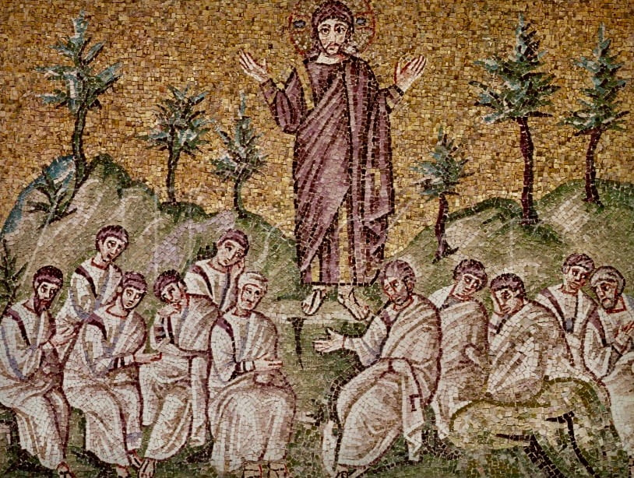
“’But I say to you that listen, Love your enemies, do good to those who hate you...’"
(Luke 6:27)

Minister: Rev. Jason Evans
First Free Methodist Church
2625 N. Center Rd.
Saginaw, Michigan 48603
Phone: (989) 799-2930
Email: saginawfmc@gmail.com
www.saginawfirstfmc.org

Seventh Sunday after the Epiphany
February 20, 2022

Prelude
**Greeting/Announcements
*Call to Worship (spoken responsively)
L: Happy are those who put their trust in the Lord
P: Who do not go astray or turn to the proud
L: God has multiplied wondrous deeds towards us
P: None can compare with God’s love
L: Sacrifice and sin offering God does not desire
P: But love your enemies, do good
L: Burnt offering and sin offering God has not required
P: But be merciful, just as your Father in heaven is merciful

*Opening Hymn: “Great is the Lord” #69 (vv.1)
Great is the Lord
He is holy and just
By His power we trust
In His love
Great is the Lord
He is faithful and true
By His mercy He proves
He is love

Great is the Lord
And worthy of glory
Great is the Lord
And worthy of praise
Great is the Lord
Now lift up your voice
Now lift up your voice
Great is the Lord
Great is the Lord

Great is the Lord,
He is holy and just
By His power we trust
In His love
Great is the Lord
He is faithful, and true
By His mercy He proves
He is love

Great is the Lord
And worthy of glory
Great is the Lord
And worthy of praise
Great is the Lord
Now lift up your voice
Now lift up your voice
Great is the Lord
Great is the Lord

Great are you Lord
And worthy of glory
Great are you Lord
And worthy of praise
Great are you Lord
I lift up my voice
I lift up my voice
Great are you Lord
Great are you Lord

*Invocation and Lord’s Prayer
L: O Lord, who has taught us that all our doings without charity are of no worth, send thy Holy Spirit and pour into our hearts that most excellent gift of charity. Instill in us the very love that is the bond of peace and of all virtues, without which whosoever lives is counted dead before you. Grant this wisdom to us as we pray the prayer that Jesus taught His disciples…

P: Our Father, who art in heaven, hallowed be Your name. Your kingdom come; your will be done in earth as it is in heaven. Give us this day our daily bread and forgive us our debts as we forgive our debtors. And lead us not into temptation but deliver us from evil. For Yours is the kingdom, and the power, and the glory forever. Amen.

*Gloria Patri
Glory be to the Father​
And to the Son and to the Holy Ghost.​
As it was in the beginning​
Is now and ever shall be.​
World without end. ​
Amen. Amen.​

First Scripture Lesson: Genesis 45:3-11, 15
Joseph said to his brothers, “I am Joseph. Is my father still alive?”
But his brothers could not answer him, so dismayed were they at his presence. Then Joseph said to his brothers, “Come closer to me.”
And they came closer. He said, “I am your brother, Joseph, whom you sold into Egypt. And now do not be distressed, or angry with yourselves, because you sold me here; for God sent me before you to preserve life. For the famine has been in the land these two years; and there are five more years in which there will be neither plowing nor harvest. God sent me before you to preserve for you a remnant on earth, and to keep alive for you many survivors.
So it was not you who sent me here, but God; he has made me a father to Pharaoh, and lord of all his house and ruler over all the land of Egypt. Hurry and go up to my father and say to him, ‘Thus says your son Joseph, God has made me lord of all Egypt; come down to me, do not delay. You shall settle in the land of Goshen, and you shall be near me, you and your children and your children's children, as well as your flocks, your herds, and all that you have. I will provide for you there--since there are five more years of famine to come--so that you and your household, and all that you have, will not come to poverty.’”
And he kissed all his brothers and wept upon them; and after that his brothers talked with him.

Prayer of Confession
L: We do think that God will love us because we are good, but that God will make us good because of God’s love. We submit to the work of the Holy Spirit, so our spirits may grow calm, our vision be clear, and our purpose be unified...

P: O my God, I love you above all things with my whole heart and soul, because you are righteous and just. I love my neighbor as myself for the love of you. I forgive all who have injured me, and ask pardon for all whom I have injured. Relying on your infinite goodness and promises, I hope to obtain pardon for my sins. By your grace, I hope to live the way you call me to. By the mercy I have received from your goodness, I will serve on your behalf those who need mercies from this life. Amen.

Affirmation of Faith: Psalm 37
P: Do not fret because of the wicked; do not be envious of wrongdoers, for they will soon fade like the grass, and wither like the green herb. Trust in the LORD, and do good; so you will live in the land, and enjoy security. Take delight in the LORD, and he will give you the desires of your heart. Commit your way to the LORD; trust in him, and he will act. Be still before the LORD, and wait patiently for him; do not fret over those who prosper in their way, over those who carry out evil devices. Refrain from anger, and forsake wrath. Do not fret--it leads only to evil. For the wicked shall be cut off, but those who wait for the LORD shall inherit the land. Yet a little while, and the wicked will be no more; though you look diligently for their place, they will not be there. But the meek shall inherit the land, and delight themselves in abundant prosperity. The salvation of the righteous is from the LORD; he is their refuge in the time of trouble.

Hymn of Affirmation: “Sweet, Sweet Spirit” #304 (vv.1-2)
There's a sweet, sweet Spirit in this place
And I know that it's the Spirit of the Lord
There are sweet expressions on each face
And I know they feel the presence of the Lord

Sweet Holy Spirit, Sweet heavenly Dove
Stay right here with us, filling us with Your love
And for these blessings we lift our hearts in praise
Without a doubt we'll know that we have been revived
When we shall leave this place

Second Scripture Lesson: 1 Corinthians 15:35-38, 42-50
But someone will ask, “How are the dead raised? With what kind of body do they come?”
Fool! What you sow does not come to life unless it dies. And as for what you sow, you do not sow the body that is to be, but a bare seed, perhaps of wheat or of some other grain. But God gives it a body as he has chosen, and to each kind of seed its own body.
So it is with the resurrection of the dead. What is sown is perishable, what is raised is imperishable. It is sown in dishonor, it is raised in glory. It is sown in weakness, it is raised in power. It is sown a physical body, it is raised a spiritual body. If there is a physical body, there is also a spiritual body.
Thus it is written, “The first man, Adam, became a living being”; the last Adam became a life-giving spirit. But it is not the spiritual that is first, but the physical, and then the spiritual. The first man was from the earth, a man of dust; the second man is from heaven. As was the man of dust, so are those who are of the dust; and as is the man of heaven, so are those who are of heaven.
Just as we have borne the image of the man of dust, we will also bear the image of the man of heaven. What I am saying, brothers and sisters, is this: flesh and blood cannot inherit the kingdom of God, nor does the perishable inherit the imperishable.

Children’s Sermon

Passing of the Peace

Prayers of the People
L: Lord in Your Mercy…
P: Hear our prayer.

Gospel Lesson: Luke 6:27-38
“But I say to you that listen, Love your enemies, do good to those who hate you, bless those who curse you, pray for those who abuse you. If anyone strikes you on the cheek, offer the other also; and from anyone who takes away your coat do not withhold even your shirt. Give to everyone who begs from you; and if anyone takes away your goods, do not ask for them again. Do to others as you would have them do to you.
“If you love those who love you, what credit is that to you? For even sinners love those who love them. If you do good to those who do good to you, what credit is that to you? For even sinners do the same. If you lend to those from whom you hope to receive, what credit is that to you? Even sinners lend to sinners, to receive as much again. But love your enemies, do good, and lend, expecting nothing in return. Your reward will be great, and you will be children of the Most High; for he is kind to the ungrateful and the wicked. Be merciful, just as your Father is merciful.
“Do not judge, and you will not be judged; do not condemn, and you will not be condemned. Forgive, and you will be forgiven; give, and it will be given to you. A good measure, pressed down, shaken together, running over, will be put into your lap; for the measure you give will be the measure you get back.”

Sermon: “”

Prayer of Response

Hymn of Response: “Joy Unspeakable” #423 (vv.1-4)
I have found His grace is all complete
He supplieth every need
While I sit and learn at Jesus’ feet
I am free, yes, free indeed
It is joy unspeakable and full of glory
Full of glory, full of glory
It is joy unspeakable and full of glory
Oh, the half has never yet been told

I have found that hope so bright and clear
Living in the realm of grace
Oh, the Savior’s presence is so near
I can see His smiling face
It is joy unspeakable and full of glory
Full of glory, full of glory
It is joy unspeakable and full of glory
Oh, the half has never yet been told

I have found the joy no tongue can tell
How its waves of glory roll
It is like a great o’erflowing well
Springing up within my soul
It is joy unspeakable and full of glory
Full of glory, full of glory
It is joy unspeakable and full of glory
Oh, the half has never yet been told

Invitation of Offering
L: We love because the love of God flows through us. We give, because the Lord has given to us. We endure, because the hope of God is in us. Give the perishable and receive the imperishable, as we collect this morning’s tithes and offerings.

*Doxology

*Prayer

*Closing Hymn: “Love Divine, All Loves Exceling” #507 (vv.1-4)
Love divine, all loves excelling, Joy of heav'n to earth come down
Fix in us thy humble dwelling, all thy faithful mercies crown
Jesus, thou art all compassion, pure, unbounded love thou art
Visit us with thy salvation, enter ev'ry trembling heart

Breathe, O breathe Thy loving Spirit, Into every troubled breast
Let us all in Thee inherit, Let us find that second rest
Take away our bent to sinning, Alpha and Omega be
End of faith, as its beginning, Set our hearts at liberty

Come, Almighty, to deliver, Let us all Thy life receive
Suddenly return and never, Nevermore Thy temples leave
Thee we would be always blessing, Serve Thee as Thy hosts above
Pray and praise Thee without ceasing, Glory in Thy perfect love

Finish, then, thy new creation, pure and spotless let us be
Let us see thy great salvation, perfectly restored in thee
Changed from glory into glory, 'til in heav'n we take our place
Til we cast our crowns before thee, lost in wonder, love, and praise

*Benediction
L: The love of God be in your heart, the grace of God be in your words, the compassion of God be in your hands, and the joy of God be in your soul. Go in peace to love and serve. Amen.

