Saginaw First Free Methodist Church
Second Sunday of Advent
December 4, 2022

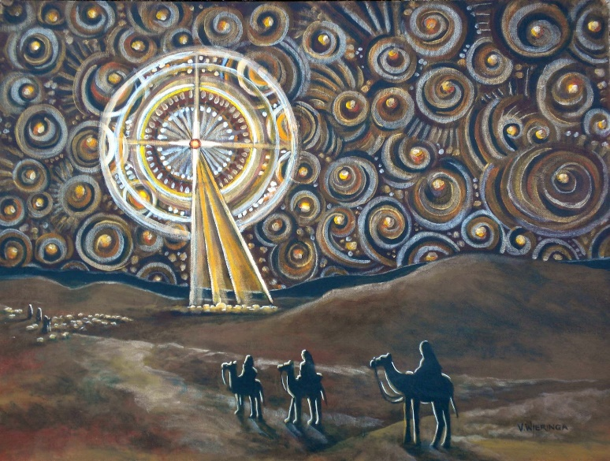
“’Repent, for the kingdom of heaven has come near.’"
(Matthew 3:2)

Minister: Rev. Jason Evans
First Free Methodist Church
2625 N. Center Rd.
Saginaw, Michigan 48603
Phone: (989) 799-2930
Email: saginawfmc@gmail.com
www.saginawfirstfmc.org

Second Sunday of Advent
December 4, 2022

Prelude
**Greeting/Announcements
*Call to Worship (spoken responsively)
L: The Lord God of Israel said, “I will send my messenger”
P: Prepare the way of the Lord, make his paths straight
L: In the desert prepare the way for the Lord
P: Every valley will be raised up; every mountain be made low
L: The glory of the Lord will be revealed
P: All mankind together will see it
L: For God will lead the people with joy, in the light of his glory
P: With the mercy and righteousness that come from on high

*Opening Hymn: “Come, Thou Long Expected Jesus” #157 (vv.1-2)
Come, thou long expected Jesus
Born to set thy people free
From our fears and sins release us
Let us find our rest in thee
Israel's strength and consolation
Hope of all the earth thou art
Dear desire of every nation
Joy of every longing heart

Born thy people to deliver
Born a child and yet a King
Born to reign in us forever
Now thy gracious kingdom bring
By thine own eternal spirit
Rule in all our hearts alone
By thine all sufficient merit
Raise us to thy glorious throne

Advent Reading

*Invocation and Lord’s Prayer
L: Merciful God, who sent your messengers he prophets to preach repentance and prepare the way for our salvation: Give us grace to heed their warnings and forsake our sins, that we may greet with joy the coming of Jesus Christ our Redeemer; who lives and reigns with you and the Holy Spirit, one God now and forever more. Teach us to wait patiently, as we pray the prayer that Jesus taught His disciples…

P: Our Father, who art in heaven, hallowed be Your name. Your kingdom come; your will be done in earth as it is in heaven. Give us this day our daily bread and forgive us our debts as we forgive our debtors. And lead us not into temptation but deliver us from evil. For Yours is the kingdom, and the power, and the glory forever. Amen.

*Gloria Patri
Glory be to the Father​
And to the Son and to the Holy Ghost.​
As it was in the beginning​
Is now and ever shall be.​
World without end. ​
Amen. Amen.​

First Scripture Lesson: Isaiah 11:1-10
A shoot shall come out from the stump of Jesse, and a branch shall grow out of his roots. The spirit of the LORD shall rest on him, the spirit of wisdom and understanding, the spirit of counsel and might, the spirit of knowledge and the fear of the LORD. His delight shall be in the fear of the LORD. He shall not judge by what his eyes see, or decide by what his ears hear; but with righteousness he shall judge the poor, and decide with equity for the meek of the earth; he shall strike the earth with the rod of his mouth, and with the breath of his lips he shall kill the wicked.
Righteousness shall be the belt around his waist, and faithfulness the belt around his loins. The wolf shall live with the lamb, the leopard shall lie down with the kid, the calf and the lion and the fatling together, and a little child shall lead them. The cow and the bear shall graze, their young shall lie down together; and the lion shall eat straw like the ox. The nursing child shall play over the hole of the asp, and the weaned child shall put its hand on the adder's den.
They will not hurt or destroy on all my holy mountain; for the earth will be full of the knowledge of the LORD as the waters cover the sea. On that day the root of Jesse shall stand as a signal to the peoples; the nations shall inquire of him, and his dwelling shall be glorious.

Prayer of Confession
L: The path of hope is paved by waiting, being quick to listen, slow to speak, and accomplishing unity in the Holy Spirit. Live patiently, so our spirits may grow calm, our vision be clear, and our purpose be unified…

P: O God the Father, creator of heaven and earth, remember not our offenses, nor the offenses of our forefathers. Reward us not according to our sins; blindness of heart, pride, vainglory and hypocrisy, but to our faithful submission to the Holy Spirit. May it please Thee to show pity upon all prisoners and captives, the homeless and the hungry, and all who are desolate and oppressed. May we please you by supporting, helping, and comforting all who are in danger, necessity, and tribulation. May we be inspired to provide for all women in childbirth, young children and orphans, the widowed, and all whose homes are broken or torn by strife. For through you and in due time, all people may enjoy the bountiful fruits of the earth. Amen.

Affirmation of Faith: Psalm 72
P: Give the king your justice, O God, and your righteousness to a king’s son. May he judge your people with righteousness, and your poor with justice. May the mountains yield prosperity for the people, and the hills, in righteousness. May he defend the cause of the poor of the people, give deliverance to the needy, and crush the oppressor. May he live while the sun endures, and as long as the moon, throughout all generations. In his days may righteousness flourish and peace abound, until the moon is no more. Blessed be the LORD, the God of Israel, who alone does wondrous things. Blessed be his glorious name forever; may his glory fill the whole earth.

Hymn of Affirmation: “Breathe On Me” #302 (vv.1-4)
Breathe on me, Breath of God
Fill me with life anew
That I may love what Thou dost love
And do what Thou would do

Breathe on me, Breath of God
Until my heart is pure
Until with Thee, I will one will
To do and to endure

Breathe on me, Breath of God
Till I am wholly Thine
Until this earthly part of me
Glows with Thy fire divine

Breathe on me, Breath of God
So shall I never die
But live with Thee the perfect life
Of Thine eternity

Second Scripture Lesson: Romans 15:4-13
For whatever was written in former days was written for our instruction, so that by steadfastness and by the encouragement of the scriptures we might have hope. May the God of steadfastness and encouragement grant you to live in harmony with one another, in accordance with Christ Jesus, that together you may with one voice glorify the God and Father of our Lord Jesus Christ.
Welcome one another, therefore, just as Christ has welcomed you, for the glory of God. For I tell you that Christ has become a servant of the circumcised on behalf of the truth of God in order that he might confirm the promises given to the patriarchs, and in order that the Gentiles might glorify God for his mercy. As it is written, “Therefore I will confess you among the Gentiles, and sing praises to your name”; and again he says, “Rejoice, O Gentiles, with his people”; and again, “Praise the Lord, all you Gentiles, and let all the peoples praise him”; and again Isaiah says, “The root of Jesse shall come, the one who rises to rule the Gentiles; in him the Gentiles shall hope.”
May the God of hope fill you with all joy and peace in believing, so that you may abound in hope by the power of the Holy Spirit.

Children’s Sermon

Passing of the Peace

Prayers of the People
L: Lord in Your Mercy…
P: Hear our prayer.

Gospel Lesson: Matthew 3:1-12
In those days John the Baptist appeared in the wilderness of Judea, proclaiming, “Repent, for the kingdom of heaven has come near.”
This is the one of whom the prophet Isaiah spoke when he said, “The voice of one crying out in the wilderness: ‘Prepare the way of the Lord, make his paths straight.’”
Now John wore clothing of camel's hair with a leather belt around his waist, and his food was locusts and wild honey. Then the people of Jerusalem and all Judea were going out to him, and all the region along the Jordan, and they were baptized by him in the river Jordan, confessing their sins.
But when he saw many Pharisees and Sadducees coming for baptism, he said to them, “You brood of vipers! Who warned you to flee from the wrath to come? Bear fruit worthy of repentance. Do not presume to say to yourselves, ‘We have Abraham as our ancestor’; for I tell you, God is able from these stones to raise up children to Abraham.
Even now the ax is lying at the root of the trees; every tree therefore that does not bear good fruit is cut down and thrown into the fire. I baptize you with water for repentance, but one who is more powerful than I is coming after me; I am not worthy to carry his sandals. He will baptize you with the Holy Spirit and fire. His winnowing fork is in his hand, and he will clear his threshing floor and will gather his wheat into the granary; but the chaff he will burn with unquenchable fire.”

Sermon: “Season For Hope”

Prayer of Response

Hymn of Response: “Jesus Shall Reign” #271 (vv.1-4)
Jesus shall reign where'er the sun
Does its successive journeys run,
His kingdom stretch from shore to shore
Till moons shall wax and wane no more

To him shall endless prayer be made,
And praises throng to crown his head.
His name like sweet perfume shall rise
With every morning sacrifice

People and realms of every tongue
Dwell on his love with sweetest song,
And infant voices shall proclaim
Their early blessings on his name

Let every creature rise and bring
The highest honors to our King,
Angels descend with songs again,
And earth repeat the loud amen

Invitation of Offering
L: By the tender mercy of our God, the dawn from on high will break upon us. It will give light to those who sit in darkness and in the shadow of death. It will answer our longing. Prepare the way of the Lord, as we collect this morning’s tithes and offerings.

*Doxology

*Prayer

*Closing Hymn: “Blessed Be the Lord God Almighty”
Father in heaven, how we love you
We lift your Name in all the earth
May your kingdom, be established in our praises
As your people declare your mighty works

Blessed be the Lord God Almighty
Who was and is, and is, to come
Blessed be the Lord God Almighty
Who reigns forever more
*Benediction
L: We Hope for the coming of Peace into our world. May we prepare the way of Peace into our world as we wait patiently, bearing one another’s burdens. Go into the world in peace to love and serve. Amen.

