Saginaw First Free Methodist Church
ADVENT
December 20, 2020

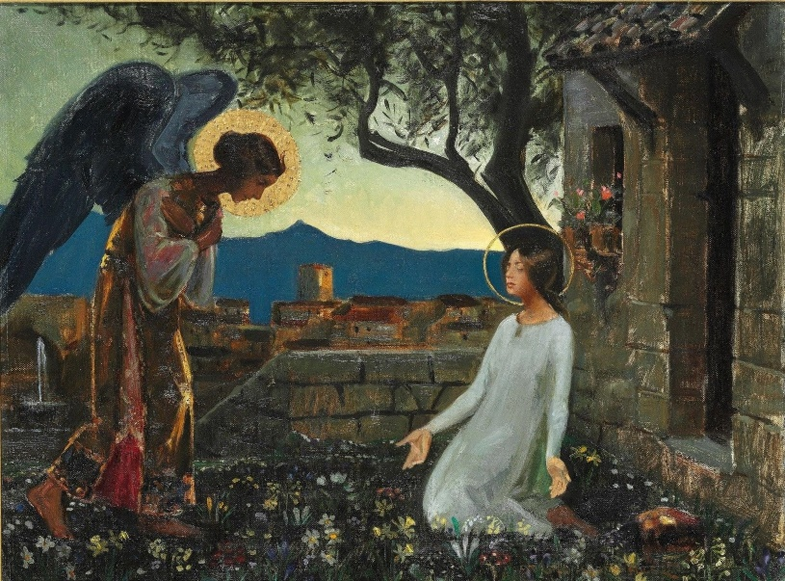
“The angel said to her, ‘The Holy Spirit will come upon you, and the power of the Most High will overshadow you; therefore, the child to be born will be holy; he will be called Son of God.’” (Luke 1:35)

Minister: Rev. Jason Evans
Instrumentalist: Dr. Malcolm Field
First Free Methodist Church
2625 N. Center Rd.
Saginaw, Michigan 48603
Phone: (989) 799-2930
Email: saginawfmc@gmail.com
www.saginawfirstfmc.org

FOURTH SUNDAY OF ADVENT
December 20, 2020

The mission of Saginaw First Free Methodist Church is to be faithful to God and to make known to all people everywhere God’s call to wholeness in Jesus Christ.

Prelude: “The Heavens are Telling”
**Greeting/Announcements
*Call to Worship (spoken responsively)
L: God is coming, the Spirit is whispering to our soul
P: We wait in hope of Christ’s return
L: God’s strength carries on to us from past generations
P: Our lives are blessed by a merciful God
L: God looks with favor on the humble and lowly
P: We will not live for rank or position in the world
L: Blessed are those who walk in God’s light
P: Let all the earth proclaim the wonders of our God

*Opening Hymn: “O Come, All Ye Faithful” #175 (v.1)
O come, all ye faithful, joyful and triumphant
O come ye, O come ye to Bethlehem
Come and behold him born the King of angels
O come, let us adore him O come, let us adore him
O come, let us adore him, Christ the Lord!

*Invocation and Lord’s Prayer
L: Ever faithful God, through prophets and angels, you promised to raise up a holy child who would establish a household of peace and justice. Open our hearts to receive your Son, that we may open our doors to welcome all people as sisters and brothers, and establish your household in our time. Make our hearts leap with joy, and fill our mouths with songs of praise, as we pray the prayer that Jesus taught His disciples…

P: Our Father, who art in heaven, hallowed be Your name. Your kingdom come; your will be done in earth as it is in heaven. Give us this day our daily bread and forgive us our debts as we forgive our debtors. And lead us not into temptation but deliver us from evil. For Yours is the kingdom, and the power, and the glory forever. Amen.

*Gloria Patri
Glory be to the Father​
And to the Son and to the Holy Ghost.
As it was in the beginning​
Is now and ever shall be
World without end
Amen. Amen
Advent Reading

Instrumental: “This day Christ Was Born”

First Scripture Lesson: 2 Samuel 7:1-11, 16
Now when the king was settled in his house, and the LORD had given him rest from all his enemies around him, the king said to the prophet Nathan, “See now, I am living in a house of cedar, but the ark of God stays in a tent.”
Nathan said to the king, “Go, do all that you have in mind; for the LORD is with you.”
But that same night the word of the LORD came to Nathan: Go and tell my servant David: Thus says the LORD: Are you the one to build me a house to live in? I have not lived in a house since the day I brought up the people of Israel from Egypt to this day, but I have been moving about in a tent and a tabernacle. Wherever I have moved about among all the people of Israel, did I ever speak a word with any of the tribal leaders of Israel, whom I commanded to shepherd my people Israel, saying, “Why have you not built me a house of cedar?”
Now therefore thus you shall say to my servant David: Thus says the LORD of hosts: I took you from the pasture, from following the sheep to be prince over my people Israel; and I have been with you wherever you went, and have cut off all your enemies from before you; and I will make for you a great name, like the name of the great ones of the earth.
And I will appoint a place for my people Israel and will plant them, so that they may live in their own place, and be disturbed no more; and evildoers shall afflict them no more, as formerly, from the time that I appointed judges over my people Israel; and I will give you rest from all your enemies. Moreover the LORD declares to you that the LORD will make you a house.
Your house and your kingdom shall be made sure forever before me; your throne shall be established forever.

Prayer of Confession
L: The promises of God are for every human being, but sometimes we seek our independence from the Giver of Life. Nothing is impossible with God, but we lack imagination. Let us confess our need for God like creativity…

P: God of promise, you have given us a sign of your love through the gift of Jesus Christ, our Savior, who was promised from ages past. We believe as Joseph did the message of your presence whispered by an angel. Remind us of our calling to make straight your paths. Teach us to offer our prayers for your world. Instill in us confidence of your care and mercy for all creation. Help us when we doubt what we cannot see or understand. Lead us gently back when we seek strength and enjoyment apart from you. Amen.

Affirmation of Faith: Psalm 89
P: I will sing of your steadfast love, O LORD, forever; with my mouth I will proclaim your faithfulness to all generations. I declare that your steadfast love is established forever; your faithfulness is as firm as the heavens. You said, “I have made a covenant with my chosen one, I have sworn to my servant David: 'I will establish your descendants forever, and build your throne for all generations.’” My faithfulness and steadfast love shall be with him; and in my name his horn shall be exalted. I will set his hand on the sea and his right hand on the rivers. He shall cry to me, ‘You are my Father, my God, and the Rock of my salvation!’

*Hymn of Affirmation: “God Rest You Merry, Gentlemen” #184 (v.1)
God rest you merry, gentlemen
Let nothing you dismay
Remember, Christ, our Savior
Was born on Christmas day
To save us all from Satan’s power
When we were gone astray
O tidings of comfort and joy
Comfort and joy
O tidings of comfort and joy

Second Scripture Lesson: Romans 16:25-27
Now to God who is able to strengthen you according to my gospel and the proclamation of Jesus Christ, according to the revelation of the mystery that was kept secret for long ages but is now disclosed, and through the prophetic writings is made known to all the Gentiles, according to the command of the eternal God, to bring about the obedience of faith; to the only wise God, through Jesus Christ, to whom be the glory forever! Amen.

Instrumental: “Shepherds and Angels”

Passing of the Peace

Prayers of the People
L: Lord in Your Mercy…
P: Hear our prayer.

Gospel Lesson: Luke 1:26-38
In the sixth month the angel Gabriel was sent by God to a town in Galilee called Nazareth, to a virgin engaged to a man whose name was Joseph, of the house of David. The virgin's name was Mary.
And he came to her and said, “Greetings, favored one! The Lord is with you.”
But she was much perplexed by his words and pondered what sort of greeting this might be.
The angel said to her, “Do not be afraid, Mary, for you have found favor with God. And now, you will conceive in your womb and bear a son, and you will name him Jesus. He will be great, and will be called the Son of the Most High, and the Lord God will give to him the throne of his ancestor David. He will reign over the house of Jacob forever, and of his kingdom there will be no end.”
Mary said to the angel, “How can this be, since I am a virgin?”
The angel said to her, “The Holy Spirit will come upon you, and the power of the Most High will overshadow you; therefore the child to be born will be holy; he will be called Son of God. And now, your relative Elizabeth in her old age has also conceived a son; and this is the sixth month for her who was said to be barren. For nothing will be impossible with God.”
Then Mary said, “Here am I, the servant of the Lord; let it be with me according to your word.” Then the angel departed from her.

Sermon

Prayer of Response

*Hymn of Response: “It Came upon the Midnight Clear” #168 (v.1)
It came upon the midnight clear
That glorious song of old
From angels bending near the earth
To touch their harps of gold
Peace on the earth, good will to men
From heaven's all-gracious King
The world in solemn stillness lay
To hear the angels sing

Invitation of Offering
L: The incarnation of God teaches us there is nothing God won’t do for us. God came as the least of these; hungry, homeless, and oppressed. Our offerings are one sign of our faithfulness to God’s mission. Give out of joy, as we collect this morning’s tithes and offerings.

Offertory: “The Angels’ Alleluia”

*Doxology
Praise God, from whom all blessings flow
Praise Him, all creatures here below
Praise Him above, ye heavenly host
Praise Father Son, and Holy Ghost.
Amen.

*Prayer

*Hymn: “Angels, From the Realms of Glory” #192 (v.1)
Angels from the realms of glory
Wing your flight o'er all the earth
Ye who sang creation's story
Now proclaim Messiah's birth
Come and worship, come and worship
Worship Christ, the newborn king

*Benediction
L: God is coming, the Spirit is whispering to our soul. Sing of God’s steadfast love as you have experienced this love in your heart. We have received the promises God has said in the past. Help others experience these promises also. Be incarnate to the vulnerable and despised, as you go in peace to love and serve. Amen.

