Saginaw First Free Methodist Church
Fourth Sunday of Advent
December 18, 2022

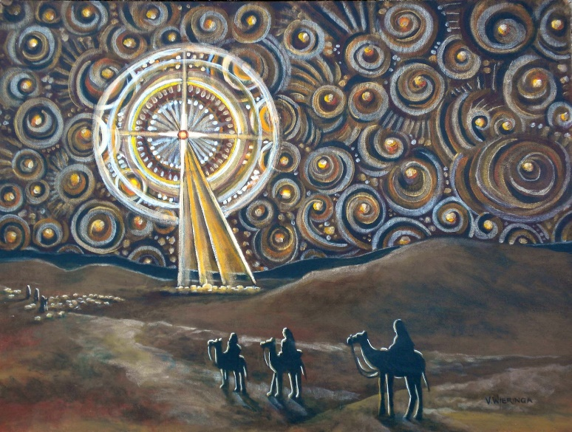
“’Look, the virgin shall conceive and bear a son, and they shall name him Emmanuel,’ which means, ‘God is with us.’"
(Matthew 1:23)

Minister: Rev. Jason Evans
First Free Methodist Church
2625 N. Center Rd.
Saginaw, Michigan 48603
Phone: (989) 799-2930
Email: saginawfmc@gmail.com
www.saginawfirstfmc.org

Fourth Sunday of Advent
December 18, 2022

Prelude
**Greeting/Announcements
*Call to Worship (spoken responsively)
Prelude
Greeting/Announcements
*Call to Worship (spoken responsively)
L: Return! O Lord our God, King of the universe
P: Reveal yourself again in the incarnation
L: Into a world of devastation and pain
P: Come hope, lift us from despair
L: Into every crooked path, unclimbable mountain, uncrossable valley
P: Come peace, restore every broken soul and broken way
L: Into every wayward life and misguided heart
P: Come joy, as we walk in the way of righteousness

*Opening Hymn: “The First Noel” #167 (vv.1-5)
The first Noel the angels did say
Was to certain poor shepherds
In fields as they lay,
In fields where they,
Laying their sheep
On a cold winter's night
That was so deep.
Noel Noel Noel Noel!
Born is the King of Israel!

They looked up and saw a star
Shining in the East beyond them far,
And to the earth it gave great light,
And so it continued both day and night.
Noel Noel Noel Noel!
Born is the King of Israel!

And by the light of that same star
Three wise men came from country far,
To seek for a King was their intent
And to follow the star
Wherever it went.
Noel Noel Noel Noel!
Born is the King of Israel!

This star drew nigh to the northwest
Over Bethlehem it took its rest,
And there it did both stop and stay
Right over the place where Jesus lay.
Noel Noel Noel Noel!
Born is the King of Israel!

Then entered in those wise men three
Full reverently upon their knee,
And offered there in His presence
Their gold, and myrrh and frankincense.
Noel Noel Noel Noel!
Born is the King of Israel!

Passing of the Peace

Advent Reading
Ho, Ho, Ho, the time is approaching, the day is near. Snow is beginning to fall and the weather outside is frightful. The streets are busy and the stores are full. It’s beginning to look a lot like Christmas!

Just as the meteorologist predicts the weather, the Prophets also have something to say about the future. “Look, the young woman is with child and shall bear a son, and shall name him Immanuel.” Isaiah tells us to be on watch for the righteous one who will come.

We, like Psalm 80 beg, “let your face shine, that we may be saved.” That we may have light, to find our way on these dark winter nights.

Paul tells us in Romans 1, it is Jesus! “The Lord is Salvation '' who is declared as God’s Son, as the Prophets foretold, through the seed of David. Through the Spirit of Holiness and the power of the resurrection.

Lighting these 4 candles, we understand that it is Love that holds us together. Love binds up what breaks in two. Love of God is why we intend to live righteous like Joseph and Love for each other is why we lay our lives down in humble submission.

*Invocation and Lord’s Prayer
L: We ask you, Almighty God, to purify our consciences by thy daily visitation, that when the Son our Lord comes, he may find in us a mansion prepared for himself; through the same Jesus Christ our Lord, who liveth and reigneth with thee, in unity of the Holy Spirit, on God, now and forever. Instill in us your love, as we pray the prayer that Jesus taught His disciples…

P: Our Father, who art in heaven, hallowed be Your name. Your kingdom come; your will be done in earth as it is in heaven. Give us this day our daily bread and forgive us our debts as we forgive our debtors. And lead us not into temptation but deliver us from evil. For Yours is the kingdom, and the power, and the glory forever. Amen.

*Gloria Patri
Glory be to the Father​
And to the Son and to the Holy Ghost.​
As it was in the beginning​
Is now and ever shall be.​
World without end. ​
Amen. Amen.​

First Scripture Lesson: Isaiah 7:10-16
Again the LORD spoke to Ahaz, saying, “Ask a sign of the LORD your God; let it be deep as Sheol or high as heaven.”
But Ahaz said, I will not ask, and I will not put the LORD to the test.
Then Isaiah said: “Hear then, O house of David! Is it too little for you to weary mortals, that you weary my God also? Therefore the Lord himself will give you a sign. Look, the young woman is with child and shall bear a son, and shall name him Immanuel. He shall eat curds and honey by the time he knows how to refuse the evil and choose the good. For before the child knows how to refuse the evil and choose the good, the land before whose two kings you are in dread will be deserted.”

Congregational Reading: Psalm 80
P: Give ear, O Shepherd of Israel, you who lead Joseph like a flock! You who are enthroned upon the cherubim, shine forth before Ephraim and Benjamin and Manasseh. Stir up your might, and come to save us! Restore us, O God; let your face shine, that we may be saved. O LORD God of hosts, how long will you be angry with your people's prayers? You have fed them with the bread of tears, and given them tears to drink in full measure. You make us the scorn of our neighbors; our enemies laugh among themselves. Restore us, O God of hosts; let your face shine, that we may be saved. But let your hand be upon the one at your right hand, the one whom you made strong for yourself. Then we will never turn back from you; give us life, and we will call on your name. Restore us, O LORD God of hosts; let your face shine, that we may be saved.

Hymn of Affirmation: “O Little Town of Bethlehem” #169 (vv.1-4)
O little town of Bethlehem
How still we see thee lie
Above thy deep and dreamless sleep
The silent stars go by
Yet in thy dark streets shineth
The everlasting light
The hopes and fears of all the years
Are met in thee tonight

For Christ is born of Mary
And, gathered all above
While mortals sleep, the angels keep
Their watch of wond’ring love
O morning stars, together
Proclaim the holy birth
And praises sing to God the King
And peace to all the earth

How silently, how silently
The wondrous gift is giv’n
So God imparts to human hearts
The blessings of his heav’n
No ear may hear his coming
But in this world of sin
Where meek souls will receive him, still
The dear Christ enters in

O holy Child of Bethlehem
Descend to us, we pray
Cast out our sin and enter in
Be born in us today
We hear the Christmas angels
The great glad tidings tell
O come to us, abide with us
Our Lord Immanuel

Second Scripture Lesson: Romans 1:1-7
Paul, a servant of Jesus Christ, called to be an apostle, set apart for the gospel of God, which he promised beforehand through his prophets in the holy scriptures, the gospel concerning his Son, who was descended from David according to the flesh and was declared to be Son of God with power according to the spirit of holiness by resurrection from the dead, Jesus Christ our Lord, through whom we have received grace and apostleship to bring about the obedience of faith among all the Gentiles for the sake of his name, including yourselves who are called to belong to Jesus Christ, to all God's beloved in Rome, who are called to be saints: Grace to you and peace from God our Father and the Lord Jesus Christ.

Special Music: Children’s Choir

Prayers of the People
L: Lord in Your Mercy…
P: Hear our prayer.

Gospel Lesson: Matthew 1:18-25
Now the birth of Jesus the Messiah took place in this way. When his mother Mary had been engaged to Joseph, but before they lived together, she was found to be with child from the Holy Spirit. Her husband Joseph, being a righteous man and unwilling to expose her to public disgrace, planned to dismiss her quietly.
But just when he had resolved to do this, an angel of the Lord appeared to him in a dream and said, “Joseph, son of David, do not be afraid to take Mary as your wife, for the child conceived in her is from the Holy Spirit. She will bear a son, and you are to name him Jesus, for he will save his people from their sins.”
All this took place to fulfill what had been spoken by the Lord through the prophet: “Look, the virgin shall conceive and bear a son, and they shall name him Emmanuel,” which means, “God is with us.”
When Joseph awoke from sleep, he did as the angel of the Lord commanded him; he took her as his wife, but had no marital relations with her until she had borne a son; and he named him Jesus.

Sermon: “The Lord is Salvation”

Prayer of Response

Hymn: “While Shepherds Watched Their Flocks” #180 vv.1-5)
While shepherds watched their flocks by night,
all seated on the ground,
the angel of the Lord came down
and glory shone around.

“Fear not,” said he – for mighty dread
had seized their troubled mind –
“Glad tidings of great joy I bring
to you and all mankind:

“To you in David’s town this day
is born of David’s line
a Saviour, who is Christ the Lord.
And this shall be the sign:

“The heavenly babe you there shall find
to human view displayed,
all meanly wrapped in swathing bands
and in a manger laid.”

“All glory be to God on high,
and to the earth be peace;
goodwill henceforth from highest heaven
begin and never cease!”

Invitation of Offering
L: In the wilderness prepare the way of the Lord, make straight in the desert a highway for our God. The glory of the Lord shall be revealed, and all flesh shall see it together. May Love reflect in our lives, as we collect this morning’s tithes and offerings.

*Doxology

*Prayer

*Closing Hymn: “Joyful, Joyful, We Adore You” #174 (vv.1-2)
Joyful joyful we adore You
God of glory Lord of light
Angels lifting praise before You
Sing throughout this holy night
In a manger lies a baby
Child of Mary Son of God
Voices joined in joyful chorus
Praise You for Your gift of love

All Your works declare Your glory
All creation joins to sing
Praise resounds as earth rejoices
In the birth of Christ the King
Shepherds kneel before the Infant
Trumpets sound and anthems raise
As with joy our hearts are lifted
Joined in wonder love and praise

*Benediction
L: May God fill you with all justice, mercy, and humility. May your hearts leap for joy. May your mouths be filled with songs of praise. May you announce glad tidings of peace. And may you welcome Christ into your midst. Go in peace to love and serve. Amen.

