Saginaw First Free Methodist Church
SECOND SUNDAY OF EASTER
April 19, 2020

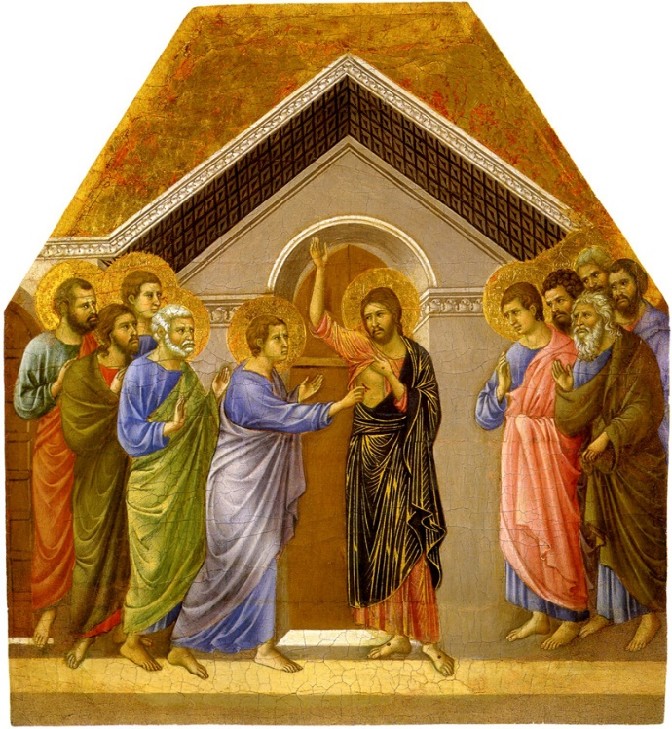

“Then he said to Thomas, ‘Put your finger here and see my hands. Reach out your hand and put it in my side. Do not doubt but believe.’ Thomas answered him, ‘My Lord and my God!’ Jesus said to him, ‘Have you believed because you have seen me? Blessed are those who have not seen and yet have come to believe.’” (John 20:27-29)

Minister: Rev. Jason Evans
First Free Methodist Church
2625 N. Center Rd.
Saginaw, Michigan 48603
Phone: (989) 799-2930
Email: saginawfmc@gmail.com
www.saginawfirstfmc.org

SECOND SUNDAY OF EASTER
April 19, 2020

The mission of Saginaw First Free Methodist Church is to be faithful to God and to make known to all people everywhere God’s call to wholeness in Jesus Christ.

Prelude
Greeting/Announcements
Call to Worship (spoken responsively)
L: We come again to celebrate resurrection
P: Death has no power over us
L: God gives us new birth into a living hope
P: Christ goes before us in the new life God offers
L: Our faith has been tested, and now is renewed
P: Our hearts are glad, our souls renewed
L: Come receive new life in Christ’s name
P: We rejoice in God’s amazing good news

*Opening Hymn: “Joyful, Joyful, We Adore Thee”

Joyful, joyful, we adore thee
God of glory, Lord of love
Hearts unfold like flowers before thee
Opening to the sun above
Melt the clouds of sin and sadness
Drive the dark of doubt away
Giver of immortal gladness
Fill us with the light of day!

All thy works with joy surround thee
Earth and heaven reflect thy rays
Stars and angels sing around thee
Center of unbroken praise
Field and forest, vale and mountain
Flowery meadow, flashing sea
Chanting bird and flowing fountain
Call us to rejoice in thee

Thou art giving and forgiving
Ever blessing, ever blest
Well-spring of the joy of living
Ocean depth of happy rest
Thou our Father, Christ our brother
All who live in love are thine
Teach us how to love each other
Lift us to the joy divine

Mortals, join the mighty chorus
which the morning stars began
Father love is reigning o'er us
Brother love binds man to man
Ever singing, march we onward
Victors in the midst of strife
Joyful music leads us sunward
In the triumph song of life

Invocation and Lord’s Prayer
L: God of peace and comfort, you come to us in our times of doubt. Show us your presence in our time of doubt and confusion. Comfort us in our times of sorrow, as we seek to comfort each other. Remove our fear and despair, remind us of your resurrection power. Confirm your presence in this world and our lives, as we pray the prayer that Jesus taught His disciples…

P: Our Father, who art in heaven, hallowed be Your name. Your kingdom come; your will be done in earth as it is in heaven. Give us this day our daily bread and forgive us our debts as we forgive our debtors. And lead us not into temptation but deliver
us from evil. For Yours is the kingdom, and the power, and the glory forever. Amen.

Gloria Patri

First Scripture Lesson: Acts 2:14, 22-32

But Peter, standing with the eleven, raised his voice and addressed them, “You that are Israelites, listen to what I have to say: Jesus of Nazareth, a man attested to you by God with deeds of power, wonders, and signs that God did through him among you, as you yourselves know this man, handed over to you according to the definite plan and foreknowledge of God, you crucified and killed by the hands of those outside the law.

But God raised him up, having freed him from death, because it was impossible for him to be held in its power. For David says concerning him, ‘I saw the Lord always before me, for he is at my right hand so that I will not be shaken; therefore my heart was glad, and my tongue rejoiced; moreover my flesh will live in hope. For you will not abandon my soul to Hades, or let your Holy One experience corruption. You have made known to me the ways of life; you will make me full of gladness with your presence.'

“Fellow Israelites, I may say to you confidently of our ancestor David that he both died and was buried, and his tomb is with us to this day. Since he was a prophet, he knew that God had sworn with an oath to him that he would put one of his descendants on his throne. Foreseeing this, David spoke of the resurrection of the Messiah, saying, ‘He was not abandoned to Hades, nor did his flesh experience corruption.’

This Jesus God raised up, and of that all of us are witnesses.

Prayer of Confession
L: We can quickly forget that we are an Easter people, even though we are raised in the power of the resurrection. Our fear can cripple our service for God’s kingdom. Let it not hider our eternal hope…

P: God of hope, these days compel us to fear. We fear losing our resources, we fear losing our health. We cling to them for comfort, and believe they sustain life. You teach us to carry our crosses, but we resist, preferring significant wealth. We believe abundant life comes from physical objects, instead of trusting in your great and many mercies. Teach us to trust in resurrection and the new life of your kingdom, instead of the insignificance of this world. Forgive us, mend our relationships to each other that have been broken by our pride and self-righteousness. Mend our trust in you and your ways. Amen.
Affirmation of Faith: Psalm 16
P: Protect me, O God, for in you I take refuge. I say to the LORD, “You are my Lord; I have no good apart from you.” Those who choose another god multiply their sorrows; their drink offerings I will not pour out or take their names upon my lips. The LORD is my chosen portion and my cup; you hold my lot. The boundary lines have fallen for me in pleasant places; I have a good heritage. I bless the LORD who gives me counsel; in the night also my heart instructs me. I keep the LORD always before me; because God is at my right hand, I shall not be moved. Therefore my heart is glad, and my soul rejoices; my body also rests secure. For you do not give me up to Sheol, or let your faithful one see the Pit. You show me the path of life. In your presence there is fullness of joy; in your right hand are pleasures forevermore.

*Hymn of Affirmation: “I Know That My Redeemer Lives”
I know that my Redeemer lives
And ever prays for me
A token of his love he gives
A pledge of liberty
I find him lifting up my head
He brings salvation near
His presence makes me free indeed
And he will soon appear

He wills that I should holy be
Who can withstand his will?
The counsel of his grace in me
He surely shall fulfil
Jesus, I hang upon your Word:
I steadfastly believe
You will return and claim me, Lord,
And to yourself receive

Thy love I soon expect to find
In all its depth and height
To comprehend th’Eternal Mind
And grasp the infinite
The bliss of those that fully dwell
Fully in Thee believe
‘Tis more than angel tongues can tell
Or angel minds conceive

New Testament Scripture Lesson: 1 Peter 1:3-9
Blessed be the God and Father of our Lord Jesus Christ! By his great mercy he has given us a new birth into a living hope through the resurrection of Jesus Christ from the dead, and into an inheritance that is imperishable, undefiled, and unfading, kept in heaven for you, who are being protected by the power of God through faith for a salvation ready to be revealed in the last time.

In this you rejoice, even if now for a little while you have had to suffer various trials, so that the genuineness of your faith--being more precious than gold that, though perishable, is tested by fire--may be found to result in praise and glory and honor when Jesus Christ is revealed. Although you have not seen him, you love him; and even though you do not see him now, you believe in him and rejoice with an indescribable and glorious joy, for you are receiving the outcome of your faith, the salvation of your souls.

Special Music: Micki Martin

Passing of the Peace

Prayers of the People
L: Lord in Your Mercy…
P: Hear our prayer.

Gospel Lesson: John 20:19-31
When it was evening on that day, the first day of the week, and the doors of the house where the disciples had met were locked for fear of the Jews, Jesus came and stood among them and said, “Peace be with you.”

After he said this, he showed them his hands and his side. Then the disciples rejoiced when they saw the Lord. Jesus said to them again, “Peace be with you. As the Father has sent me, so I send you.”

When he had said this, he breathed on them and said to them, “Receive the Holy Spirit. If you forgive the sins of any, they are forgiven them; if you retain the sins of any, they are retained.”

But Thomas (who was called the Twin), one of the twelve, was not with them when Jesus came. So the other disciples told him, “We have seen the Lord.” But he said to them, “Unless I see the mark of the nails in his hands, and put my finger in the mark of the nails and my hand in his side, I will not believe.”

A week later his disciples were again in the house, and Thomas was with them. Although the doors were shut, Jesus came and stood among them and said, “Peace be with you.”

Then he said to Thomas, “Put your finger here and see my hands. Reach out your hand and put it in my side. Do not doubt but believe.”

Thomas answered him, “My Lord and my God!”

Jesus said to him, “Have you believed because you have seen me? Blessed are those who have not seen and yet have come to believe.”

Now Jesus did many other signs in the presence of his disciples, which are not written in this book. But these are written so that you may come to believe that Jesus is the Messiah, the Son of God, and that through believing you may have life in his name.

Sermon

Prayer of Response

Hymn of Response: “Love Divine, All Loves Excelling”
Love divine, all loves excelling, Joy of heav'n to earth come down
Fix in us thy humble dwelling, all thy faithful mercies crown
Jesus, thou art all compassion, pure, unbounded love thou art
Visit us with thy salvation, enter ev'ry trembling heart

Breathe, O breathe thy loving Spirit, into ev'ry troubled breast
Let us all in thee inherit, let us find the second rest
Take away our bent to sinning, Alpha and Omega be
End of faith, as its Beginning, set our hearts at liberty

Finish, then, thy new creation, pure and spotless let us be
Let us see thy great salvation, perfectly restored in thee
Changed from glory into glory, 'til in heav'n we take our place
Til we cast our crowns before thee, lost in wonder, love, and praise

Invitation of Offering
L: Let us express our thanks to God for coming to bring us peace and comfort. We are blessed beyond all measure, and our cups overflow. Show the world life is more important than silver, as we collect this morning’s tithes and offerings.

*Doxology

Prayer

Closing Hymn: “God’s Eye Is on the Sparrow”

Why should I feel discouraged?
Why should the shadows come?
Why should my heart be lonely
And long for heaven and home
When Jesus is my portion?
My constant friend is he
His eye is on the sparrow
And I know he watches me
His eye is on the sparrow
And I know he watches me
I sing because I’m happy
I sing because I’m free
For his eye is on the sparrow
And I know he watches me

Whenever I am tempted
Whenever clouds arise
When song gives place to sighing
When hope within me dies
I draw the closer to him
From care he sets me free
His eye is on the sparrow
And I know he watches me
His eye is on the sparrow
And I know he watches me
I sing because I’m happy
I sing because I’m free
For his eye is on the sparrow
And I know he watches me
Benediction
L: God is with us, God is for us, and God’s peace is with you every moment of every day. The God of resurrection has touched you and healed your unbelief. You are empowered as disciples and apostles, go in peace to love and serve. Amen.

