Saginaw First Free Methodist Church
THIRD SUNDAY OF EASTER
April 18, 2021

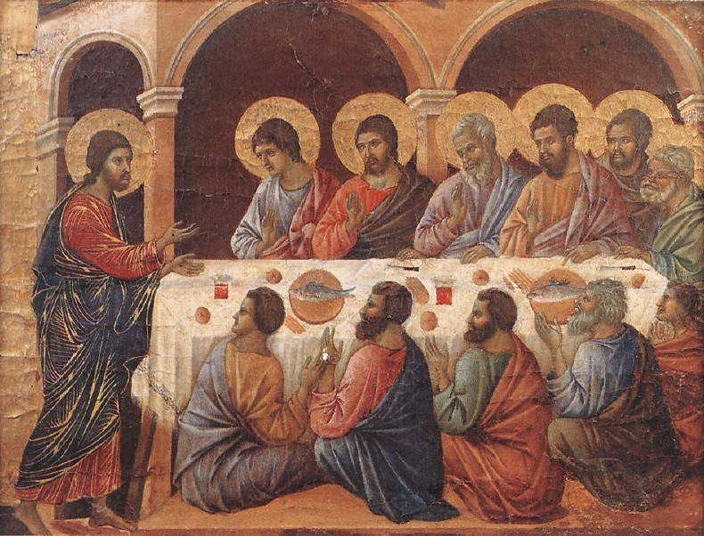
“While in their joy they were disbelieving and still wondering, he said to them, ‘Have you anything here to eat?’ They gave him a piece of broiled fish, and he took it and ate in their presence.”
(Luke 24:41-43)

Minister: Rev. Jason Evans
First Free Methodist Church
2625 N. Center Rd.
Saginaw, Michigan 48603
Phone: (989) 799-2930
Email: saginawfmc@gmail.com
www.saginawfirstfmc.org

THIRD SUNDAY OF EASTER
April 18, 2021
Prelude
**Greeting/Announcements
*Call to Worship (spoken responsively)
L: The Holy and Righteous One, the Author of life was killed
P: God raised him from the dead
L: God fulfilled what was promised through all the prophets
P: The Messiah would suffer, die, and be buried
L: We proclaim repentance and forgiveness of sins in Jesus’ name
P: Because He rose from the dead on the third day
L: All who do what is right, are righteous, just as He is righteous
P: We are children of God, and witnesses to the truth

*Opening Hymn: “Thine is the Glory” #264 (vv.1-3)
Thine be the glory, risen, conqu’ring Son
Endless is the vict’ry Thou o’er death hast won
Angels in bright raiment rolled the stone away
Kept the folded grave-clothes, where Thy body lay
Thine be the glory, risen, conqu’ring Son
Endless is the vict’ry Thou o’er death hast won

Lo! Jesus meets us, risen from the tomb
Lovingly He greets us, scatters fear and gloom
Let the Church with gladness, hymns of triumph sing
For her Lord now liveth, death hath lost its sting
Thine be the glory, risen, conqu’ring Son
Endless is the vict’ry Thou o’er death hast won

No more we doubt Thee, Prince of Life
Life is naught without Thee, aid us in our strife
Make us more than conqu’rors, thro’ Thy deathless love
Bring us safely thro’ Jordan, to Thy home above
Thine be the glory, risen, conqu’ring Son
Endless is the vict’ry Thou o’er death hast won

*Invocation and Lord’s Prayer
L: God who created us and sustains us, because of your love you call us your children. Open our minds to the scriptures, that we may be one with you and each other. May the Holy Spirit guide us in all righteousness, that we may be like you. Teach us to abide with you, that on the last day, no sin may be found in us. Let our hope be in you and the power of your resurrection, as we pray the prayer that Jesus taught His disciples…

P: Our Father, who art in heaven, hallowed be Your name. Your kingdom come; your will be done in earth as it is in heaven. Give us this day our daily bread and forgive us our debts as we forgive our debtors. And lead us not into temptation but deliver us from evil. For Yours is the kingdom, and the power, and the glory forever. Amen.

*Gloria Patri
Glory be to the Father​
And to the Son and to the Holy Ghost.
As it was in the beginning​
Is now and ever shall be
World without end
Amen. Amen

First Scripture Lesson: Acts 3:12-19
When Peter saw it, he addressed the people, “You Israelites, why do you wonder at this, or why do you stare at us, as though by our own power or piety we had made him walk? The God of Abraham, the God of Isaac, and the God of Jacob, the God of our ancestors has glorified his servant Jesus, whom you handed over and rejected in the presence of Pilate, though he had decided to release him.
But you rejected the Holy and Righteous One and asked to have a murderer given to you, and you killed the Author of life, whom God raised from the dead. To this we are witnesses. And by faith in his name, his name itself has made this man strong, whom you see and know; and the faith that is through Jesus has given him this perfect health in the presence of all of you.
“And now, friends, I know that you acted in ignorance, as did also your rulers. In this way God fulfilled what he had foretold through all the prophets, that his Messiah would suffer. Repent therefore, and turn to God so that your sins may be wiped out.”

Prayer of Confession
L: Our doubt can lead us to wonder and disbelief; even when we are in God’s presence. At times we act in ignorance. For our continuous search for peace, let us recite from Psalm 4 together…

P: Answer me when I call, O God of my right! You gave me room when I was in distress. Be gracious to me, and hear my prayer. How long, you people, shall my honor suffer shame? How long will you love vain words, and seek after lies? But know that the LORD has set apart the faithful for himself; the LORD hears when I call to him. When you are disturbed, do not sin; ponder it on your beds, and be silent. Offer right sacrifices, and put your trust in the LORD.

Affirmation of Faith: Apostle’s Creed
P: I believe in God, the Father Almighty, Maker of heaven and earth. And in Jesus Christ, God’s only Son, our Lord. Who was conceived by the Holy Spirit, born of the Virgin Mary, suffered under Pontius Pilate, was crucified, dead, and was buried. He descended into hades, the third day He rose again from the dead. He ascended into heaven, and sits at the right hand of God the Father Almighty. From thence He shall come to judge the living and the dead. I believe in the Holy Spirit, the holy Church universal, the communion of saints, the forgiveness of sins, the resurrection of the body, and the life everlasting. Amen.

Hymn of Affirmation: “Jesus, the Very Thought of Thee” #139 (vv.1,3,5)
Jesus the very thought of Thee
With sweetness fills my breast
But sweeter far Thy face to see
And in Thy presence rest

O hope of every contrite heart
O joy of all the meek
To those who fall, how kind Thou art
How good to those who seek

Jesus, our only joy be Thou
As Thou our prize wilt be
Jesus, be Thou our glory now
And thro’ eternity

New Testament Scripture Lesson: 1 John 3:1-7
See what love the Father has given us, that we should be called children of God; and that is what we are. The reason the world does not know us is that it did not know him. Beloved, we are God's children now; what we will be has not yet been revealed. What we do know is this: when he is revealed, we will be like him, for we will see him as he is.
And all who have this hope in him purify themselves, just as he is pure. Everyone who commits sin is guilty of lawlessness; sin is lawlessness. You know that he was revealed to take away sins, and in him there is no sin. No one who abides in him sins; no one who sins has either seen him or known him. Little children, let no one deceive you. Everyone who does what is right is righteous, just as he is righteous.

Passing of the Peace

Prayers of the People
L: Lord in Your Mercy…
P: Hear our prayer.

Gospel Lesson: Luke 24:36b-48
While they were talking about this, Jesus himself stood among them and said to them, “Peace be with you.”
They were startled and terrified, and thought that they were seeing a ghost. He said to them, “Why are you frightened, and why do doubts arise in your hearts? Look at my hands and my feet; see that it is I myself. Touch me and see; for a ghost does not have flesh and bones as you see that I have.”
And when he had said this, he showed them his hands and his feet. While in their joy they were disbelieving and still wondering, he said to them, “Have you anything here to eat?”
They gave him a piece of broiled fish, and he took it and ate in their presence. Then he said to them, “These are my words that I spoke to you while I was still with you--that everything written about me in the law of Moses, the prophets, and the psalms must be fulfilled.”
Then he opened their minds to understand the scriptures, and he said to them, “Thus it is written, that the Messiah is to suffer and to rise from the dead on the third day, and that repentance and forgiveness of sins is to be proclaimed in his name to all nations, beginning from Jerusalem. You are witnesses of these things.”

Sermon

Prayer of Response

Hymn of Response: “Lord, Speak to Me That I May Speak” (vv.1-5)
Lord, speak to me that I may speak
In living echoes of your tone
As you have sought, so let me seek
Your erring children lost and lone

O lead me, Lord, that I may lead
The wandering and the wavering feet
O feed me, Lord, that I may feed
Your hungering ones with mana sweet

O teach me, Lord, that I may teach
The precious truths which you impart
And wing my words that they may reach
The hidden depths of many a heart

O fill me with your fullness, Lord
Until my very heart o’er-flow
In kindling thought and glowing word
Your love to tell, your praise to show

O use me, Lord, even me
Just as you will, and when, and where
Until your blessed face I see
Your rest, your joy, your glory share

Invitation of Offering
L: God has put gladness in our hearts, so we may be at peace in our lives. As children of God, let us abide with God, who is our protector and provider. Let us share God’s love in return, as we collect this morning’s tithes and offerings.

*Doxology
Praise God, from whom all blessings flow
Praise Him, all creatures here below
Praise Him above, ye heavenly host
Praise Father Son, and Holy Ghost.
Amen.

*Prayer

*Closing Hymn: “How Great Thou Art” #33 (vv.1,3-4)
O Lord, my God, when I in awesome wonder
Consider all the worlds Thy hands have made
I see the stars, I hear the rolling thunder
Thy power throughout the universe displayed
Then sings my soul, my Savior God, to Thee
How great Thou art, how great Thou art
Then sings my soul, my Savior God, to Thee
How great Thou art, how great Thou art

And when I think of God, His Son not sparing
Sent Him to die, I scarce can take it in
That on the Cross, my burden gladly bearing
He bled and died to take away my sin
Then sings my soul, my Savior God, to Thee
How great Thou art, how great Thou art
Then sings my soul, my Savior God, to Thee
How great Thou art, how great Thou art

When Christ shall come with shout of acclamation
And take me home, what joy shall fill my heart
Then I shall bow with humble adoration
And then proclaim, my God, how great Thou art
Then sings my soul, my Savior God, to Thee
How great Thou art, how great Thou art
Then sings my soul, my Savior God, to Thee
How great Thou art, how great Thou art
*Benediction
L: May God be on your hearts and minds all the day long. Abide in God, and live righteously as Christ did. Live in hope, as you go in peace to love and serve. Amen.

